DISTRICT GIS PARAKH
District GIS Parakh – Mobile & Web Application
Asset Survey User Manual
संपत्ति सर्वेक्षण उपयोगकर्ता मैनुअल
User Creation & Approval → Asset Creation → Assign Asset to User → Asset Survey



Version: 1.2
Prepared for: PHED / MPSSDI / Departments on District GIS Parakh
Prepared by: Parakh – MPSEDC (Madhya Pradesh State Electronics Development Center)
Date: 24-Jul-2026

Document Version History
Version | Date | Author | Comments
V_1.0 | 24-Jul-2026 | Dheeraj Motiyani | Initial draft — Asset Survey User Manual (Bilingual EN/HI)

Contents
Document Version History 2
Table of Contents 3
1. Introduction 4
1.1 Purpose 4
1.2 Scope 4
2. Roles & Responsibilities 4
3. Pre-Requisites 5
4. Process Overview – Asset Survey Workflow 5
5. Step 1: User Creation & Approval 5
5.1 Hierarchy of User Creation 5
5.2 Creating a New User 6
5.3 Approving a User 7
6. Step 2: Asset Creation 7
6.1 Creating a Single Asset 8
6.2 Bulk Asset Upload 8
7. Step 3: Assign Asset to Department User 9
7.1 Assign for Inspection & Survey (one-time) 10
7.2 Assign for Data Collection (recurring) 10
8. Step 4: Conducting the Asset Survey 11
8.1 On the Mobile Application 11
8.2 On the Web Application 11
8.3 Draft and Submitted Forms 11
9. Validation & Exception Handling 12
9.1 Form Validation Rules 12
9.2 Exception Handling 12
10. Reports 12
11. Compliance & Audit Guidelines 12
1. परिचय 13
1.1 उद्देश्य 13
1.2 कार्यक्षेत्र (Scope) 13
2. भूमिका एवं जिम्मेदारियाँ 13
3. पूर्व-आवश्यकताएँ 14
4. प्रक्रिया अवलोकन – संपत्ति सर्वेक्षण कार्यप्रवाह 14
5. चरण 1: उपयोगकर्ता निर्माण एवं अनुमोदन 15
5.1 उपयोगकर्ता निर्माण का अनुक्रम (Hierarchy) 15
5.2 नया उपयोगकर्ता बनाना 15
5.3 उपयोगकर्ता को अनुमोदित करना 16
6. चरण 2: संपत्ति (Asset) निर्माण 17
6.1 एकल संपत्ति बनाना 17
6.2 बल्क एसेट अपलोड 17
7. चरण 3: संपत्ति को विभागीय उपयोगकर्ता को आवंटित करना 19
7.1 निरीक्षण एवं सर्वेक्षण हेतु आवंटन (एक बार) 19
7.2 डेटा संग्रह हेतु आवंटन (आवर्ती) 20
8. चरण 4: संपत्ति सर्वेक्षण करना 21
8.1 मोबाइल एप्लिकेशन पर 21
8.2 वेब एप्लिकेशन पर 21
8.3 ड्राफ्ट एवं सबमिट किए गए फॉर्म 22
9. सत्यापन एवं अपवाद प्रबंधन 22
9.1 फॉर्म सत्यापन नियम 22
9.2 अपवाद प्रबंधन 22
10. रिपोर्ट 22
11. अनुपालन एवं ऑडिट दिशानिर्देश 22

Part A — English
1. Introduction
2. Roles & Responsibilities
3. Pre-Requisites
4. Process Overview – Asset Survey Workflow
5. Step 1: User Creation & Approval
6. Step 2: Asset Creation
7. Step 3: Assign Asset to Department User
8. Step 4: Conducting the Asset Survey
9. Validation & Exception Handling
10. Reports

Part B — हिंदी (Hindi)
1. परिचय
2. भूमिका एवं जिम्मेदारियाँ
3. पूर्व-आवश्यकताएँ
4. प्रक्रिया अवलोकन – संपत्ति सर्वेक्षण कार्यप्रवाह
5. चरण 1: उपयोगकर्ता निर्माण एवं अनुमोदन
6. चरण 2: संपत्ति (Asset) निर्माण
7. चरण 3: संपत्ति को विभागीय उपयोगकर्ता को आवंटित करना
8. चरण 4: संपत्ति सर्वेक्षण करना
9. सत्यापन एवं अपवाद प्रबंधन
10. रिपोर्ट

PART A — ENGLISH

1. Introduction

1.1 Purpose
This Asset Survey User Manual explains, end-to-end, how a Department on the District GIS Parakh platform (Mobile & Web) takes a government asset from creation through to a completed field survey. It covers the complete chain: Department issues a circular authorising onboarding of officers → User Creation & Approval (role-wise hierarchy) → Asset Creation → Assigning the Asset to a Department User (Nodal Officer assigns to Reporting Officer, Reporting Officer assigns to Inspector) → the Inspector conducts the Asset Survey on the assigned asset via the mobile application.

1.2 Scope
- User Creation & Approval (State Admin → Nodal Officer → Reporting Officer → Inspector)
- Asset Creation (single entry and bulk upload)
- Assignment of Asset to Department User for Inspection & Survey, and for recurring Data Collection
- Conducting the Asset Survey on the Mobile and Report on Web applications
- Draft handling, submission, validation and reporting of survey data

2. Roles & Responsibilities
Field | Description
Department | Issues the circular authorising the rollout of the Asset Survey exercise and directs the creation of user accounts for its officers on Parakh.
State Admin / Super Admin | Highest-level account (created by MPSEDC). Creates the Nodal Officer profile for the Department, creates Designations, and can create Assets, Forms, and Questions for any department.
Nodal Officer | Created by the State Admin. Creates and approves the Reporting Officer profile (typically at divisional/district level). Assigns Assets to Reporting Officers for inspection & survey or data collection.
Reporting Officer (RO) | Created and approved by the Nodal Officer. Assigns the Asset further down to the Inspector / Field Officer responsible for the ground-level survey. Monitors submitted and pending surveys under their jurisdiction.
Inspector / Field Officer | Created and approved by the Reporting Officer. Receives the Asset assignment and conducts the physical Asset Survey/Inspection using the mobile application, submitting or saving the form as a draft.

NOTE / नोट: As per District, Tehsil and Block, the Reporting Officer will obtain approval from the concerned Department before an Inspector profile is finally activated.

3. Pre-Requisites
- A signed Department circular/authorisation to onboard officers on Parakh for the Asset Survey.
- Valid State Admin / Nodal Officer login credentials.
- Parakh mobile application installed (Android) or the Parakh Web Portal URL, for Reporting Officers and Inspectors.
- Active internet/data connectivity (offline draft-save is available if the network drops mid-survey).
- The Asset(s) to be surveyed already defined in the system, or the data required to create them (name, type, location, department).

4. Process Overview – Asset Survey Workflow
The Asset Survey exercise on any asset follows this fixed sequence:
- Department issues a circular directing that officers be onboarded on Parakh for the Asset Survey.
- User Creation & Approval – State Admin creates the Nodal Officer; Nodal Officer creates/approves the Reporting Officer (RO); the Reporting Officer creates/approves the Inspector.
- Asset Creation – the State Admin / Nodal Officer creates the Asset (or a batch of Assets via Excel - bulk upload) under the concerned Department.
- Assign Asset to Department User – the Nodal Officer assigns the Asset to the Reporting Officer; the Reporting Officer, in turn, assigns the same Asset to the Inspector for ground-level Inspection & Survey.
- Asset Survey – the Inspector opens the assigned Asset on the mobile application, fills the survey/inspection form with photos, geo-tag and other required details, and submits it (or saves it as a draft if incomplete).
- Submitted data is stored centrally and is visible to the Reporting Officer, Nodal Officer and State Admin through the Reports section.

NOTE / नोट: Short form: Nodal assigns the Asset to the RO → RO assigns it to the Inspector → Department issues the circular so that user accounts can be created → users are created → the Asset survey is then carried out by the Inspector.

5. Step 1: User Creation & Approval

5.1 Hierarchy of User Creation
- State Admin → creates the Nodal Officer profile for the Department.
- Nodal Officer → creates the Reporting Officer (RO) profile and approves it after validation.
- Reporting Officer → creates the Inspector / Field Officer profile and approves it after validation.
This hierarchy ensures every account on the Asset Survey chain is created and validated by the officer immediately above it, before it can be used to receive an Asset assignment.

5.2 Creating a New User
- Log in with the admin credentials appropriate to your role (State Admin / Nodal Officer / Reporting Officer).
- From the left menu, click Masters → Create User.
- Fill in the new user's details:
  - Name
  - Mobile Number
  - Email ID
  - Role / Designation (e.g., Nodal Officer, Reporting Officer, Inspector)
  - Department
  - Office / Jurisdiction (e.g., District, Division)
- Click Add User. The account is created and appears in the User List, initially in a pending-approval state where applicable.
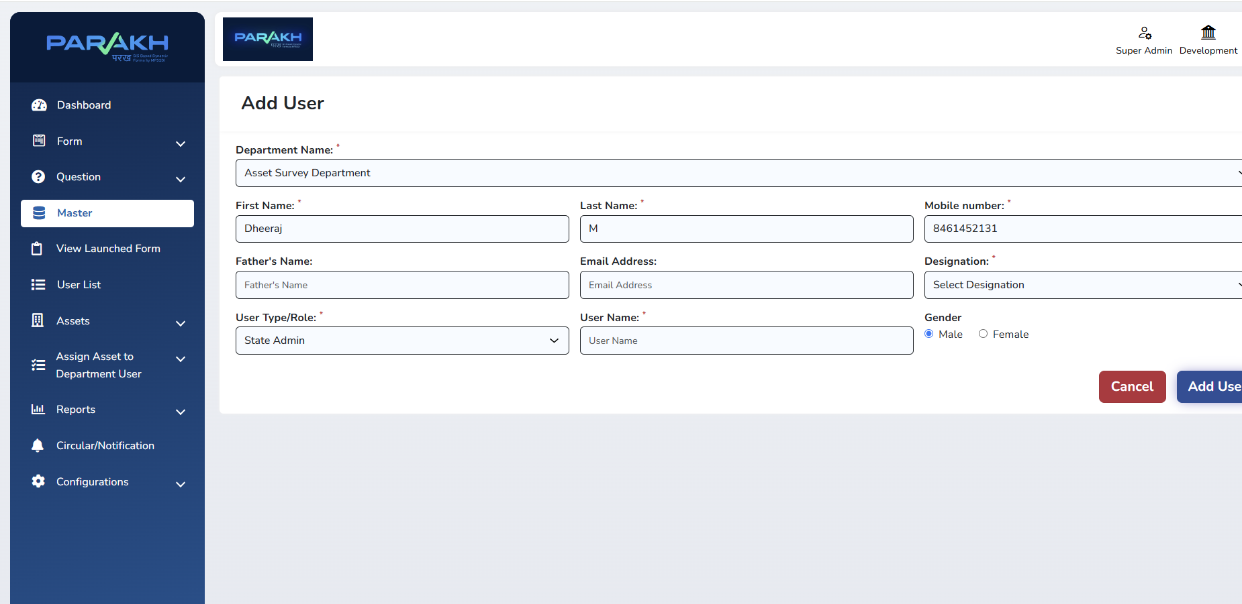
User account creation form – personal, contact and department details
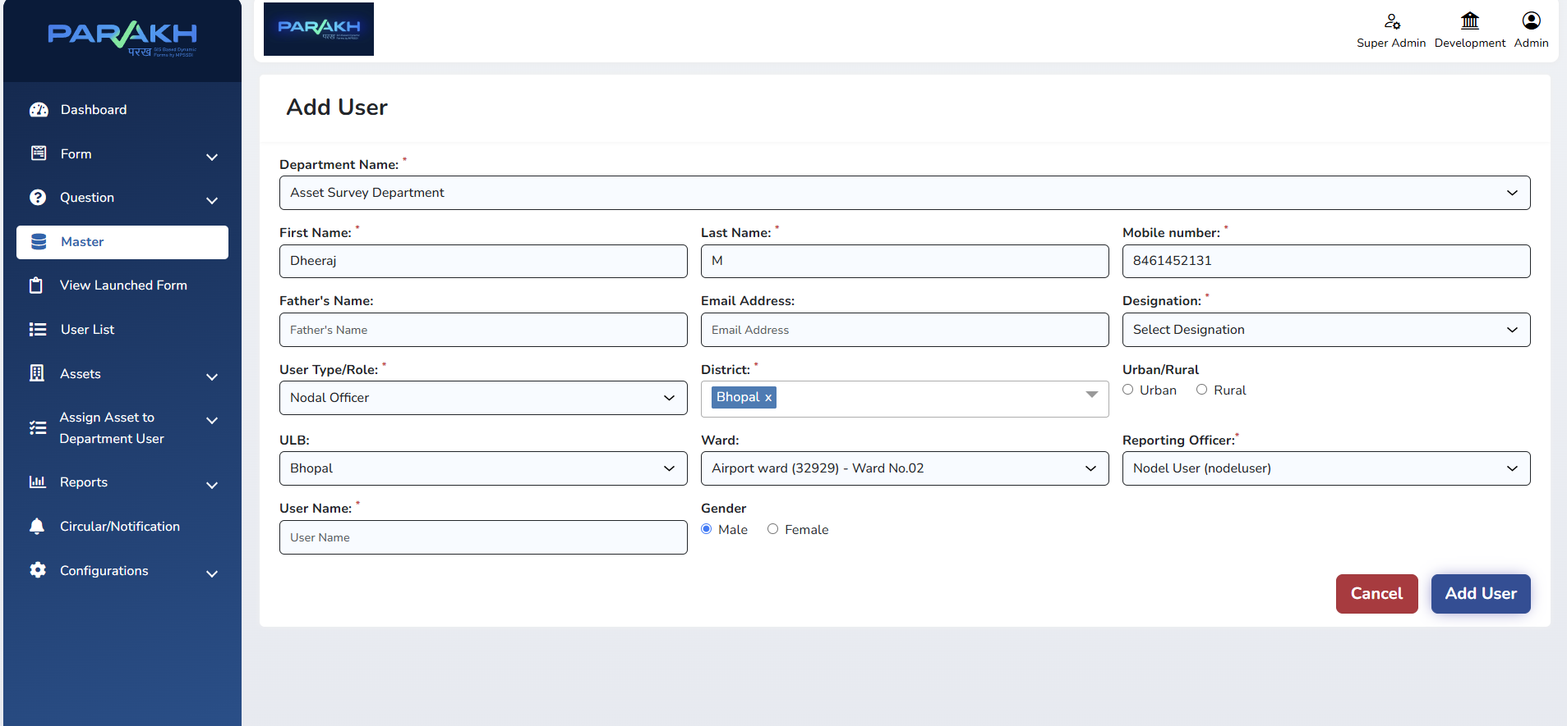
User account creation form – role and department assignment

5.3 Approving a User
- The approving officer (Nodal Officer for an RO, or Reporting Officer for an Inspector) opens Masters → User List.
- Locate the newly created user and open their profile.
- Verify the details submitted against the Department circular / authorisation.
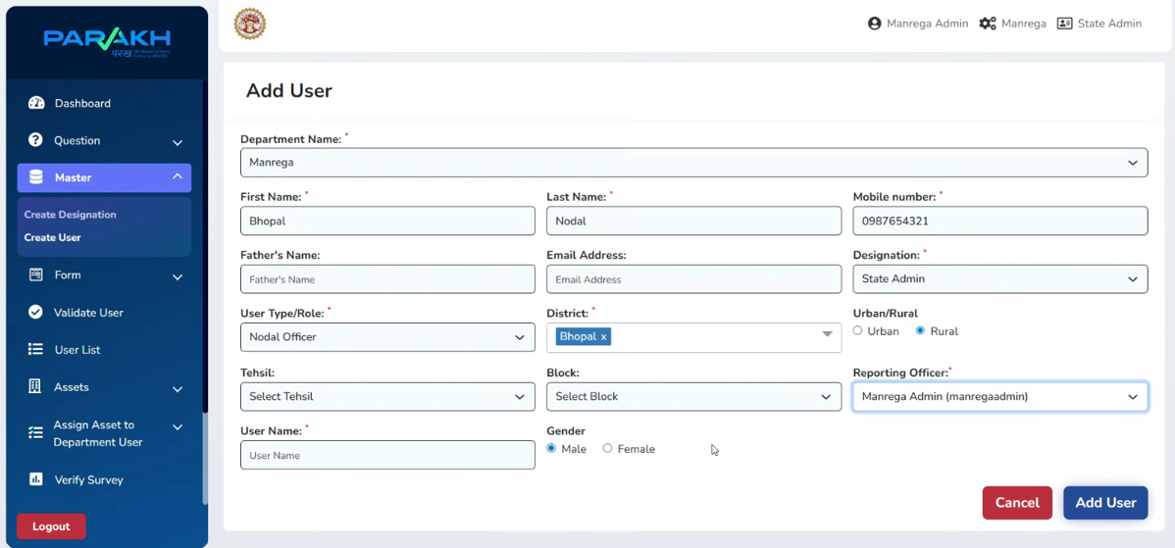
User creation & approval screen
Once added, the user can log in to the mobile application and is available for selection when an Asset is assigned.

6. Step 2: Asset Creation
An Asset must exist in the system before it can be assigned to any Department User for survey. Assets are created by the State Admin or Nodal Officer under the concerned Department.

6.1 Creating a Single Asset
- Under Assets Menu → Add Asset.
- Fill in the asset details.
Field | Description
Department Name | The department under which the asset is being created (e.g., PHED, SAPS, School Education).
Asset Name & Type | Name and category of the asset (e.g., government building, open plot, hand pump, hostel).
Business Name / Legal Name | Formal name under which the asset is registered, where applicable.
Location Details | Address, District, Tehsil/Block, and map coordinates (geo-tag) of the asset.
Contact Details | Mobile number and address of the concerned contact for the asset, if any.
Status | Is Active – Yes/No, to control whether the asset is currently available for assignment.
- Click Save / Add Asset to add it to the Asset List.

6.2 Bulk Asset Upload
When a large number of assets need to be added together, use the Bulk Upload option: download the prescribed Excel template, fill in the asset details along with the Department name, and upload the file. The system validates and adds all valid rows to the Asset List.
And Below screen explains when we add single Asset:
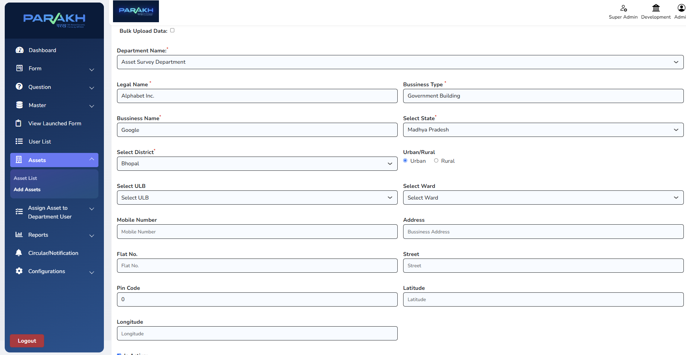
Add Assets screen

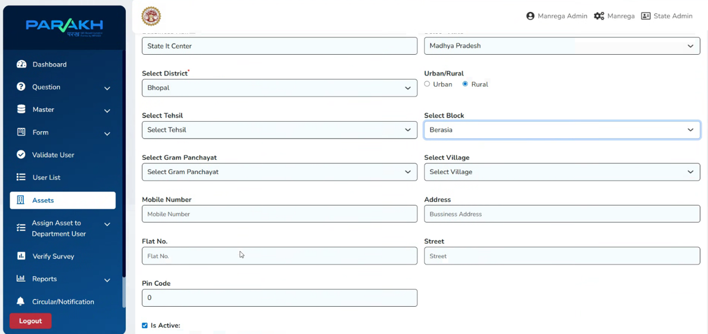
Asset creation form – district, urban/rural and department fields
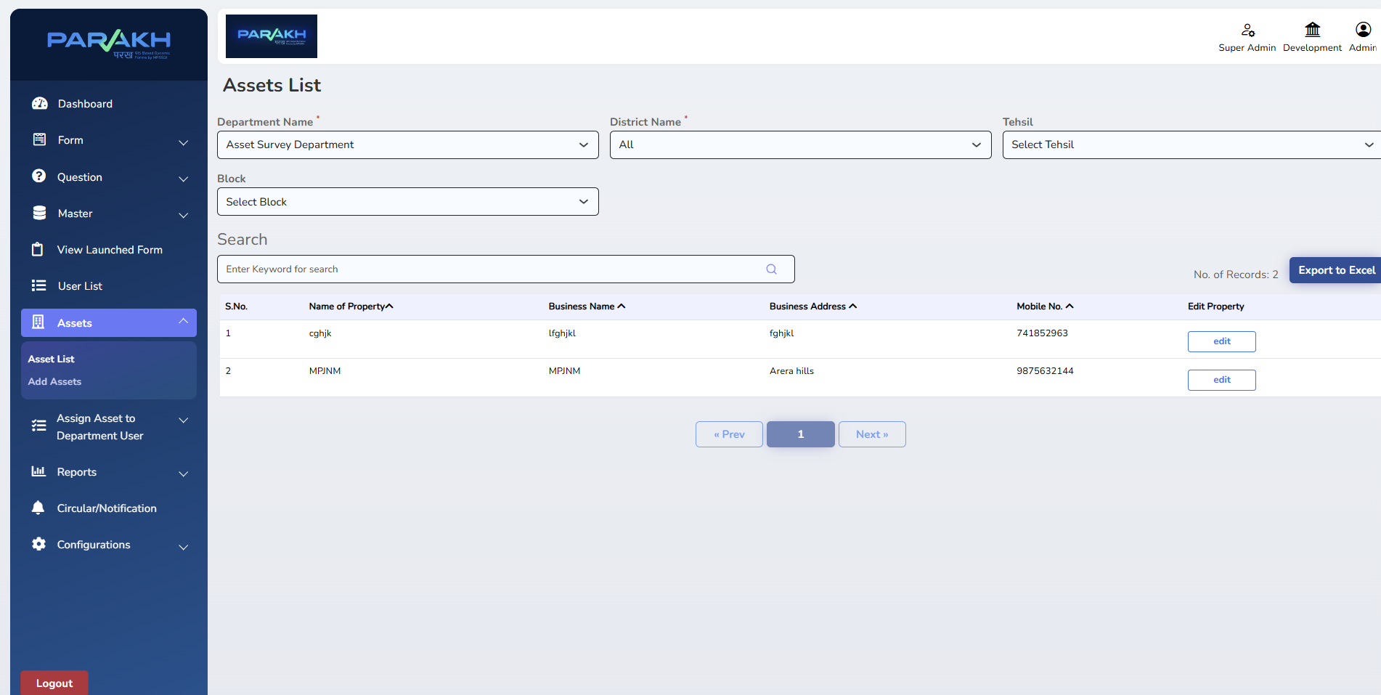
Asset List – view, search and manage all created assets

7. Step 3: Assign Asset to Department User
Once an Asset exists, it must be assigned down the hierarchy — first by the Nodal Officer to the Reporting Officer, and then by the Reporting Officer to the Inspector — before any survey can be carried out on it. There are two assignment modes:

7.1 Assign for Inspection & Survey (one-time)
Used when the asset needs a one time inspection or survey.
- Go to Assign Asset to Department User → Assign for Inspection & Survey.
- Select Department Name (e.g., SAPS / PHED).
- Select District Name (e.g., Bhopal).
- Select Tehsil (optional).
- Select Form – the inspection/survey form to be used (e.g., LSK Inspection Form).
- Select Department User – the officer to whom the asset is being assigned (Nodal selects the RO; RO selects the Inspector).
- Use the Is Allotted filter (Yes/No) to check which assets are already assigned and which are still pending assignment.
- Click Assign / Search to confirm.
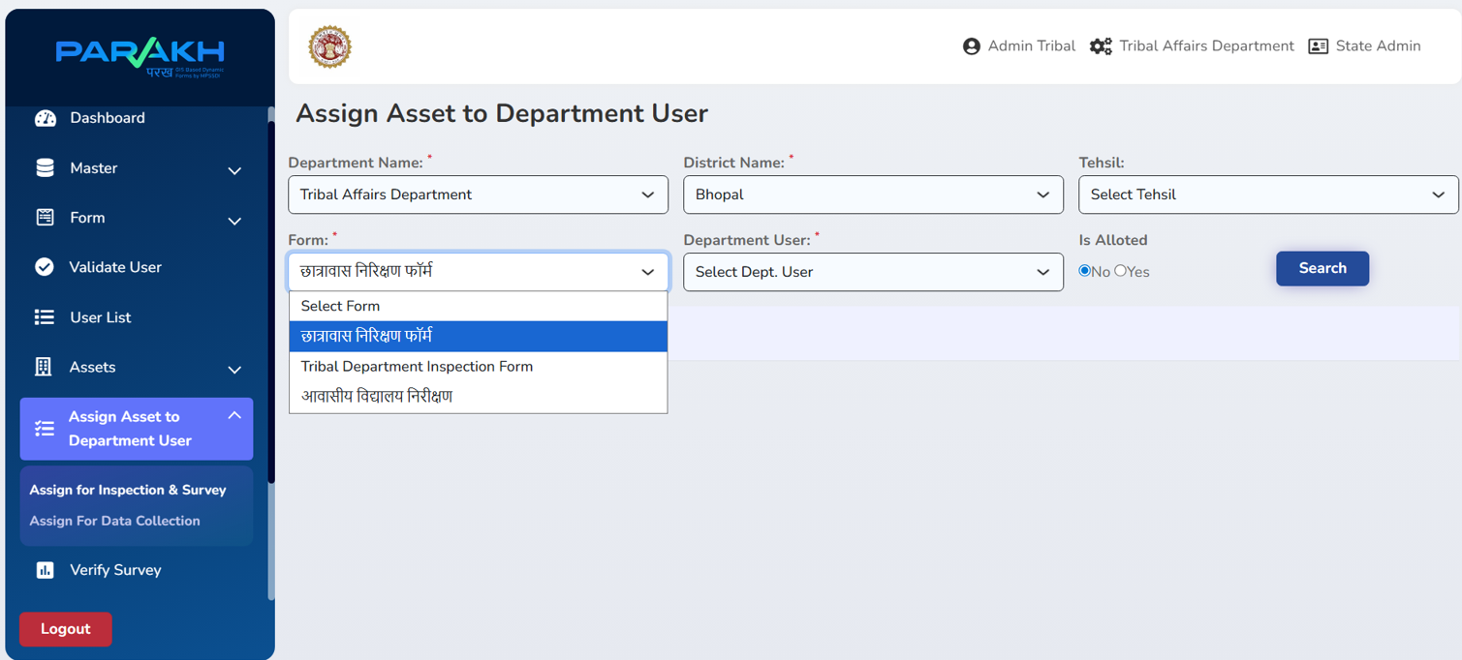
Assign Asset for Inspection & Survey to a Department User

7.2 Assign for Data Collection (recurring)
Used for assets that require periodic data collection or survey at a fixed interval, rather than a single one-time inspection.
- Go to Assign Asset to Department User → Assign for Data Collection.
- Select Frequency – Monthly, Quarterly, Half-Yearly, or Yearly.
- Enter From Date and To Date for the assignment period.
- Click View Proposed Allocation Dates to preview the survey/data-collection dates the system will generate.
- Select Department Name, District Name, Tehsil (optional) and Form.
- Select the Department User to whom the asset/data-collection responsibility is being assigned.
- Click Search / Assign to confirm the recurring assignment.
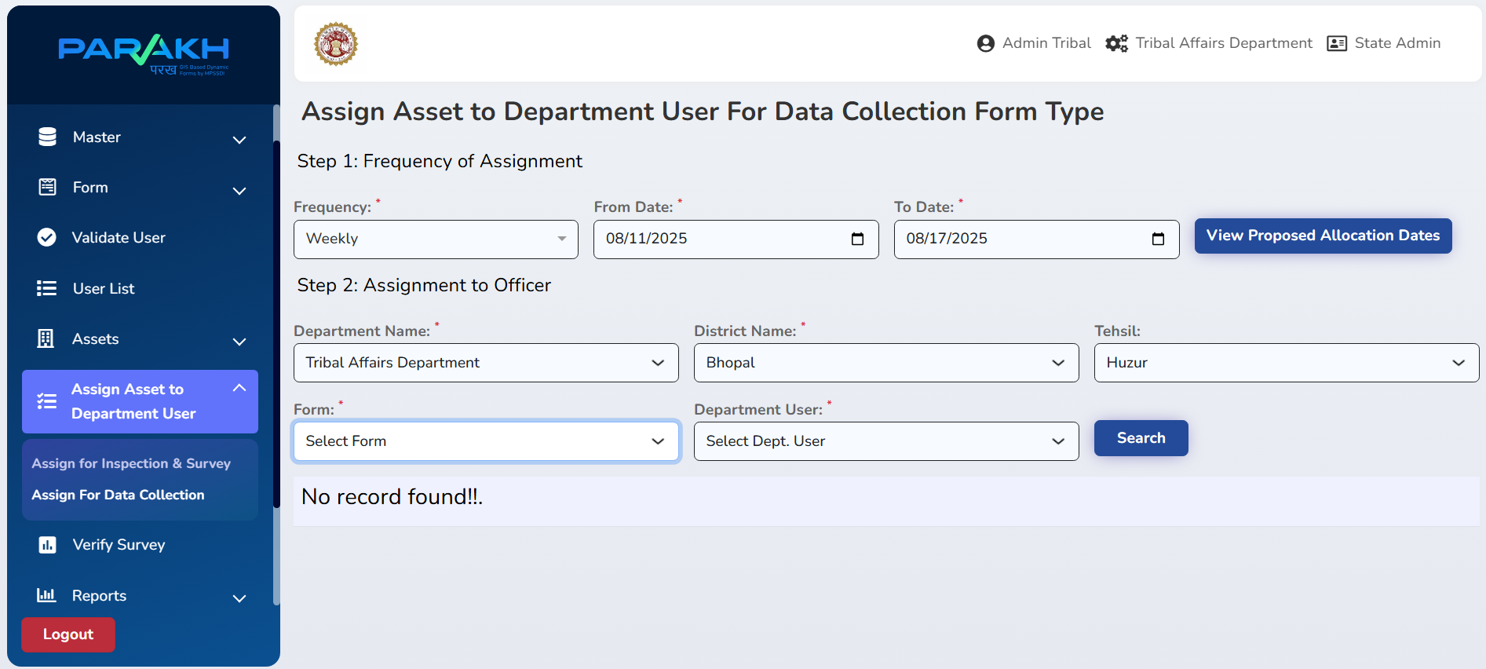
Assign Asset to Department User for Data Collection

NOTE / नोट: The assigned Inspector will now see this asset on their mobile/web dashboard under Field Inspection & Survey, ready to be surveyed.

8. Step 4: Conducting the Asset Survey

8.1 On the Mobile Application
- Log in to the Parakh mobile app as a Department user (Inspector).
- From the dashboard, tap Field Survey Modules → Asset Survey Form.
- Tap the Filter icon and select the relevant Inspection Area (e.g., park, anganwadi, health care) if prompted, then Apply Filter.
- All assets assigned to you appear on the map as red pin markers, each representing one location to be surveyed.
- Tap a red pin to open the survey form for that specific asset.
- Fill in all required fields carefully, including photographs and geo-tag capture where required.
- Tap Submit once the form is complete, or Save as Draft if you need to finish it later (e.g., due to a network issue).

8.2 On the Web Application
- Log in to the Parakh Web Portal as Department, using your username and password.
- Open the assigned Asset from your dashboard/asset list and can check assigned asset.
- Also, can see the Report for Asset surveyed in web portal.

8.3 Draft and Submitted Forms
- Save As Draft – temporarily stores a partially completed form so it can be reopened and finished later.
- Visited Sites / Submitted Forms – shows all forms that have been fully completed and submitted.

9. Validation & Exception Handling

9.1 Form Validation Rules
- Mandatory fields must be completed before submission.
- Duplicate survey entries on the same asset are flagged by the system.
- Invalid or unauthorised user attempts are logged.

9.2 Exception Handling
- If survey data is incomplete, the system prompts the user to re-enter the missing fields.
- If a user account is not yet approved, that user cannot log in or access any forms.
- If an asset has not been assigned to the logged-in user, it will not appear in their survey list.
- If there is a network failure while filling the form, data is stored offline on the device and synced automatically once connectivity is restored.

10. Reports
Field | Description
Completed Surveys & Inspection Report | All fully completed surveys and inspections, filterable by Department.
Surveys & Inspections Form Report | Search survey/inspection submissions by Department, District, Reporting Officer, and User.
General Form Report | All submitted forms for a selected Department and Form Name.
Sudden Inspection Report | Unannounced inspections carried out by department officers, including inspector, date, institution type, site, remarks and photos.
Asset Survey Report | Digital survey record of departmental assets (e.g., government buildings, open plots) for review and analysis.

11. Compliance & Audit Guidelines
This manual, and the Asset Survey workflow it documents, follows CMMI Level 5 practices, ensuring:
- Continuous improvement of the user-creation, asset-assignment and survey workflows.
- Performance monitoring of survey and inspection processes.
- Data governance and traceability of every form submission back to the assigned user and asset.
- A standardised, hierarchy-based approval process for all user management (State Admin → Nodal Officer → Reporting Officer → Inspector).

भाग B — हिंदी (PART B — HINDI)

1. परिचय

1.1 उद्देश्य
यह संपत्ति सर्वेक्षण उपयोगकर्ता मैनुअल विस्तार से यह बताता है कि District GIS Parakh प्लेटफ़ॉर्म (मोबाइल एवं वेब) पर किसी विभाग की किसी भी सरकारी संपत्ति (Asset) पर निर्माण से लेकर मैदानी सर्वेक्षण पूर्ण होने तक की पूरी प्रक्रिया कैसे संपन्न होती है। इसमें पूरी श्रृंखला शामिल है: विभाग द्वारा अधिकारियों को Parakh पर जोड़ने हेतु परिपत्र (circular) जारी करना → उपयोगकर्ता निर्माण एवं अनुमोदन (भूमिका-अनुसार अनुक्रम) → संपत्ति (Asset) निर्माण → संपत्ति को विभागीय उपयोगकर्ता को आवंटित करना (नोडल अधिकारी रिपोर्टिंग अधिकारी को आवंटित करता है, रिपोर्टिंग अधिकारी इंस्पेक्टर को आवंटित करता है) → इंस्पेक्टर द्वारा मोबाइल या वेब एप्लिकेशन के माध्यम से आवंटित संपत्ति पर सर्वेक्षण करना।

1.2 कार्यक्षेत्र (Scope)
- उपयोगकर्ता निर्माण एवं अनुमोदन (State Admin → नोडल अधिकारी → रिपोर्टिंग अधिकारी → इंस्पेक्टर)
- संपत्ति निर्माण (एकल प्रविष्टि एवं बल्क अपलोड)
- निरीक्षण एवं सर्वेक्षण हेतु तथा आवर्ती डेटा संग्रह हेतु संपत्ति को विभागीय उपयोगकर्ता को आवंटन
- मोबाइल एवं वेब एप्लिकेशन पर संपत्ति सर्वेक्षण करना
- ड्राफ्ट प्रबंधन, सबमिशन, सत्यापन एवं सर्वेक्षण डेटा की रिपोर्टिंग

2. भूमिका एवं जिम्मेदारियाँ
फील्ड | विवरण
विभाग (Department) | संपत्ति सर्वेक्षण कार्य के क्रियान्वयन हेतु परिपत्र जारी करता है और अपने अधिकारियों के लिए Parakh पर उपयोगकर्ता खाते बनाने का निर्देश देता है।
State Admin / सुपर एडमिन | सर्वोच्च स्तर का खाता (MPSEDC द्वारा बनाया गया)। विभाग हेतु नोडल अधिकारी प्रोफ़ाइल बनाता है, पद (Designation) बनाता है, तथा किसी भी विभाग हेतु संपत्ति, फॉर्म एवं प्रश्न बना सकता है।
नोडल अधिकारी (Nodal Officer) | State Admin द्वारा बनाया जाता है। रिपोर्टिंग अधिकारी (आमतौर पर संभाग/जिला स्तर पर) की प्रोफ़ाइल बनाता है एवं सत्यापन के बाद उसे अनुमोदित करता है। निरीक्षण व सर्वेक्षण अथवा डेटा संग्रह हेतु संपत्तियाँ रिपोर्टिंग अधिकारियों को आवंटित करता है।
रिपोर्टिंग अधिकारी (RO) | नोडल अधिकारी द्वारा बनाया एवं अनुमोदित किया जाता है। मैदानी सर्वेक्षण हेतु जिम्मेदार इंस्पेक्टर/फील्ड ऑफिसर को संपत्ति आगे आवंटित करता है। अपने क्षेत्राधिकार में सबमिट व लंबित सर्वेक्षणों की निगरानी करता है।
इंस्पेक्टर / फील्ड ऑफिसर | रिपोर्टिंग अधिकारी द्वारा बनाया एवं अनुमोदित किया जाता है। संपत्ति आवंटन प्राप्त कर मोबाइल या वेब एप्लिकेशन के माध्यम से भौतिक संपत्ति सर्वेक्षण/निरीक्षण करता है तथा फॉर्म सबमिट करता है या ड्राफ्ट के रूप में सेव करता है।
नोट: जिले, तहसील और ब्लॉक के अनुसार, रिपोर्टिंग अधिकारी, इंस्पेक्टर प्रोफ़ाइल के अंतिम सक्रियण से पूर्व संबंधित विभाग से अनुमोदन प्राप्त करेंगे।

3. पूर्व-आवश्यकताएँ
- संपत्ति सर्वेक्षण कार्य हेतु Parakh पर अधिकारियों को जोड़ने के लिए विभाग का हस्ताक्षरित परिपत्र/प्राधिकरण।
- वैध State Admin / नोडल अधिकारी लॉगिन क्रेडेंशियल्स।
- रिपोर्टिंग अधिकारी एवं इंस्पेक्टर हेतु Parakh मोबाइल एप्लिकेशन (Android) इंस्टॉल्ड, अथवा Parakh वेब पोर्टल का URL।
- सक्रिय इंटरनेट/डेटा कनेक्टिविटी (सर्वेक्षण के दौरान नेटवर्क बाधित होने पर ऑफ़लाइन ड्राफ्ट-सेव उपलब्ध है)।
- सर्वेक्षण की जाने वाली संपत्ति(यों) सिस्टम में पहले से परिभाषित हों, या उन्हें बनाने हेतु आवश्यक डेटा (नाम, प्रकार, स्थान, विभाग) उपलब्ध हो।

4. प्रक्रिया अवलोकन – संपत्ति सर्वेक्षण कार्यप्रवाह
किसी भी संपत्ति पर सर्वेक्षण कार्य निम्नलिखित निश्चित क्रम में होता है:
- विभाग एक परिपत्र जारी करता है जिसमें संपत्ति सर्वेक्षण हेतु अधिकारियों को Parakh पर जोड़ने का निर्देश होता है।
- उपयोगकर्ता निर्माण एवं अनुमोदन – State Admin नोडल अधिकारी बनाता है; नोडल अधिकारी रिपोर्टिंग अधिकारी (RO) बनाता/अनुमोदित करता है; रिपोर्टिंग अधिकारी इंस्पेक्टर बनाता/अनुमोदित करता है।
- संपत्ति निर्माण – State Admin / नोडल अधिकारी संबंधित विभाग के अंतर्गत संपत्ति (या Excel के माध्यम से संपत्तियों का समूह) बनाता है।
- संपत्ति को विभागीय उपयोगकर्ता को आवंटित करना – नोडल अधिकारी संपत्ति रिपोर्टिंग अधिकारी को आवंटित करता है; रिपोर्टिंग अधिकारी वही संपत्ति मैदानी निरीक्षण एवं सर्वेक्षण हेतु इंस्पेक्टर को आवंटित करता है।
- संपत्ति सर्वेक्षण – इंस्पेक्टर मोबाइल/वेब एप्लिकेशन पर आवंटित संपत्ति खोलता है, फोटो, जियो-टैग एवं अन्य आवश्यक जानकारी सहित सर्वेक्षण/निरीक्षण फॉर्म भरता है, और उसे सबमिट करता है (अथवा अधूरा होने पर ड्राफ्ट के रूप में सेव करता है)।
- सबमिट किया गया डेटा केंद्रीय रूप से संग्रहीत होता है तथा Reports सेक्शन के माध्यम से रिपोर्टिंग अधिकारी, नोडल अधिकारी एवं State Admin को दिखाई देता है।
नोट: संक्षेप में: नोडल संपत्ति RO को आवंटित करता है → RO उसे इंस्पेक्टर को आवंटित करता है → विभाग परिपत्र जारी करता है ताकि उपयोगकर्ता खाते बनाए जा सकें → उपयोगकर्ता बनाए जाते हैं → इसके बाद इंस्पेक्टर द्वारा संपत्ति सर्वेक्षण किया जाता है।

5. चरण 1: उपयोगकर्ता निर्माण एवं अनुमोदन

5.1 उपयोगकर्ता निर्माण का अनुक्रम (Hierarchy)
- State Admin → विभाग हेतु नोडल अधिकारी प्रोफ़ाइल बनाता है।
- नोडल अधिकारी → रिपोर्टिंग अधिकारी (RO) प्रोफ़ाइल बनाता है एवं सत्यापन के बाद अनुमोदित करता है।
- रिपोर्टिंग अधिकारी → इंस्पेक्टर/फील्ड ऑफिसर प्रोफ़ाइल बनाता है एवं सत्यापन के बाद अनुमोदित करता है।
यह अनुक्रम सुनिश्चित करता है कि संपत्ति सर्वेक्षण श्रृंखला में प्रत्येक खाता, संपत्ति आवंटन प्राप्त करने से पहले, ठीक ऊपर वाले अधिकारी द्वारा बनाया एवं सत्यापित किया जाए।

5.2 नया उपयोगकर्ता बनाना
- अपनी भूमिका (State Admin / नोडल अधिकारी / रिपोर्टिंग अधिकारी) के अनुरूप एडमिन क्रेडेंशियल्स से लॉगिन करें।
- बाएँ मेनू में Masters → Create User पर क्लिक करें।
- नए उपयोगकर्ता का विवरण भरें:
  - नाम (Name)
  - मोबाइल नंबर (Mobile Number)
  - ईमेल आईडी (Email ID)
  - रोल/पद (जैसे नोडल अधिकारी, रिपोर्टिंग अधिकारी, इंस्पेक्टर)
  - विभाग (Department)
  - कार्यालय/क्षेत्राधिकार (जैसे जिला, संभाग)
- Add User पर क्लिक करें। खाता बन जाता है और User List में दिखाई देता है; जहाँ लागू हो, वहाँ प्रारंभ में यह अनुमोदन-प्रतीक्षारत स्थिति में रहता है।

उपयोगकर्ता खाता निर्माण फॉर्म – व्यक्तिगत, संपर्क एवं विभागीय विवरण

उपयोगकर्ता खाता निर्माण फॉर्म – रोल एवं विभाग आवंटन

5.3 उपयोगकर्ता को अनुमोदित करना
- अनुमोदन करने वाला अधिकारी (RO हेतु नोडल अधिकारी, अथवा इंस्पेक्टर हेतु रिपोर्टिंग अधिकारी) Masters → User List खोलता है।
- नव-निर्मित उपयोगकर्ता को खोजकर उसकी प्रोफ़ाइल खोलें।
- विभागीय परिपत्र/प्राधिकरण के अनुसार सबमिट किए गए विवरण सत्यापित करें।
- खाता सक्रिय करने हेतु Approve पर क्लिक करें, अथवा विवरण गलत होने पर टिप्पणी सहित Reject करें।

उपयोगकर्ता निर्माण एवं अनुमोदन स्क्रीन
अनुमोदन के पश्चात उपयोगकर्ता मोबाइल या वेब एप्लिकेशन में लॉगिन कर सकता है, और जब कोई संपत्ति आवंटित की जाती है तो वह चयन हेतु उपलब्ध रहता है।

6. चरण 2: संपत्ति (Asset) निर्माण
किसी भी संपत्ति को सर्वेक्षण हेतु किसी विभागीय उपयोगकर्ता को आवंटित करने से पहले उसका सिस्टम में मौजूद होना आवश्यक है। संपत्तियाँ संबंधित विभाग के अंतर्गत State Admin या नोडल अधिकारी द्वारा बनाई जाती हैं।

6.1 एकल संपत्ति बनाना
- Masters → Assets → Add Asset पर जाएँ।
- संपत्ति का विवरण भरें।
फील्ड | विवरण
विभाग का नाम (Department Name) | वह विभाग जिसके अंतर्गत संपत्ति बनाई जा रही है (जैसे PHED, SAPS, स्कूल शिक्षा)।
संपत्ति का नाम एवं प्रकार | संपत्ति का नाम एवं श्रेणी (जैसे सरकारी भवन, खुला प्लॉट, हैंडपंप, छात्रावास)।
बिज़नेस नेम / लीगल नेम | जहाँ लागू हो, संपत्ति जिस औपचारिक नाम से पंजीकृत है।
स्थान विवरण (Location Details) | पता, जिला, तहसील/ब्लॉक, तथा संपत्ति के मानचित्र निर्देशांक (जियो-टैग)।
संपर्क विवरण | यदि लागू हो तो संपत्ति से संबंधित व्यक्ति का मोबाइल नंबर एवं पता।
स्थिति (Status) | Is Active – Yes/No, यह नियंत्रित करने हेतु कि संपत्ति वर्तमान में आवंटन हेतु उपलब्ध है या नहीं।
- संपत्ति को Asset List में जोड़ने हेतु Save / Add Asset पर क्लिक करें।

6.2 बल्क एसेट अपलोड
जब एक साथ बड़ी संख्या में संपत्तियाँ जोड़नी हों, तो Bulk Upload विकल्प का उपयोग करें: निर्धारित Excel टेम्पलेट डाउनलोड करें, विभाग के नाम सहित संपत्ति का विवरण भरें, और फ़ाइल अपलोड करें। सिस्टम सभी मान्य पंक्तियों को सत्यापित कर Asset List में जोड़ देता है।

संपत्ति निर्माण फॉर्म – जिला, शहरी/ग्रामीण एवं विभाग फील्ड

Add Assets स्क्रीन

Asset List – बनाई गई सभी संपत्तियों को देखना, खोजना एवं प्रबंधित करना

7. चरण 3: संपत्ति को विभागीय उपयोगकर्ता को आवंटित करना
संपत्ति बनने के बाद, उस पर कोई भी सर्वेक्षण किए जाने से पहले उसे अनुक्रम के अनुसार आवंटित करना आवश्यक है — पहले नोडल अधिकारी द्वारा रिपोर्टिंग अधिकारी को, फिर रिपोर्टिंग अधिकारी द्वारा इंस्पेक्टर को। आवंटन के दो तरीके हैं:

7.1 निरीक्षण एवं सर्वेक्षण हेतु आवंटन (एक बार)
जब संपत्ति पर एक बार का निरीक्षण या सर्वेक्षण करना हो, तब इसका उपयोग किया जाता है।
- Assign Asset to Department User → Assign for Inspection & Survey पर जाएँ।
- Department Name चुनें (जैसे SAPS / PHED)।
- District Name चुनें (जैसे Bhopal)।
- Tehsil चुनें (वैकल्पिक)।
- Form चुनें – जिसका उपयोग निरीक्षण/सर्वेक्षण हेतु किया जाना है (जैसे LSK Inspection Form)।
- Department User चुनें – जिस अधिकारी को संपत्ति आवंटित की जा रही है (नोडल, RO का चयन करता है; RO, इंस्पेक्टर का चयन करता है)।
- यह जाँचने हेतु कि कौन-सी संपत्तियाँ पहले से आवंटित हैं और कौन-सी लंबित हैं, Is Allotted फ़िल्टर (Yes/No) का उपयोग करें।
- पुष्टि हेतु Assign / Search पर क्लिक करें।

निरीक्षण एवं सर्वेक्षण हेतु संपत्ति को विभागीय उपयोगकर्ता को आवंटित करना

7.2 डेटा संग्रह हेतु आवंटन (आवर्ती)
जिन संपत्तियों पर एक निश्चित अंतराल पर आवर्ती डेटा संग्रह या सर्वेक्षण आवश्यक है (न कि केवल एक बार का निरीक्षण), उनके लिए इसका उपयोग किया जाता है।
- Assign Asset to Department User → Assign for Data Collection पर जाएँ।
- Frequency चुनें – Monthly, Quarterly, Half-Yearly, अथवा Yearly।
- आवंटन अवधि हेतु From Date एवं To Date दर्ज करें।
- सिस्टम द्वारा प्रस्तावित सर्वेक्षण/डेटा-संग्रह तिथियाँ देखने हेतु View Proposed Allocation Dates पर क्लिक करें।
- Department Name, District Name, Tehsil (वैकल्पिक) एवं Form चुनें।
- वह Department User चुनें जिसे संपत्ति/डेटा-संग्रह की जिम्मेदारी आवंटित की जा रही है।
- आवर्ती आवंटन की पुष्टि हेतु Search / Assign पर क्लिक करें।

डेटा संग्रह हेतु संपत्ति को विभागीय उपयोगकर्ता को आवंटित करना
नोट: अब आवंटित इंस्पेक्टर को अपने मोबाइल/वेब डैशबोर्ड पर Field Inspection & Survey के अंतर्गत यह संपत्ति दिखाई देगी, जो सर्वेक्षण हेतु तैयार है।

8. चरण 4: संपत्ति सर्वेक्षण करना

8.1 मोबाइल एप्लिकेशन पर
- Parakh मोबाइल ऐप में विभागीय उपयोगकर्ता (इंस्पेक्टर) के रूप में लॉगिन करें।
- डैशबोर्ड से, Field Inspection & Survey → Asset Survey Form पर टैप करें।
- यदि संकेत मिले तो Filter आइकन पर टैप करें और संबंधित Inspection Area (जैसे park, aanganwadi, health care) चुनें, फिर Apply Filter करें।
- आपको आवंटित सभी संपत्तियाँ मानचित्र पर लाल पिन (Red Markers) के रूप में दिखाई देती हैं, प्रत्येक पिन सर्वेक्षण किए जाने वाले एक स्थान को दर्शाता है।
- उस विशिष्ट संपत्ति का सर्वेक्षण फॉर्म खोलने हेतु किसी लाल पिन पर टैप करें।
- आवश्यकतानुसार फोटोग्राफ एवं जियो-टैग सहित सभी आवश्यक फील्ड सावधानीपूर्वक भरें।
- फॉर्म पूर्ण होने पर Submit पर टैप करें, अथवा बाद में पूरा करना हो (जैसे नेटवर्क समस्या के कारण) तो Save as Draft पर टैप करें।

8.2 वेब एप्लिकेशन पर
- अपने यूज़रनेम एवं पासवर्ड से Department के रूप में Parakh वेब पोर्टल में लॉगिन करें।
- अपने डैशबोर्ड/एसेट लिस्ट से आवंटित Asset खोलें।
- मोबाइल प्रक्रिया जैसे ही विवरण के साथ सर्वेक्षण/निरीक्षण फॉर्म भरें, तथा Submit या Save as Draft करें।

8.3 ड्राफ्ट एवं सबमिट किए गए फॉर्म
- Save As Draft – आंशिक रूप से भरे गए फॉर्म को अस्थायी रूप से सहेजता है, जिसे बाद में पुनः खोलकर पूरा किया जा सकता है।
- Visited Sites / Submitted Forms – उन सभी फॉर्मों को दर्शाता है जो पूर्ण रूप से भरे जाकर सबमिट किए जा चुके हैं।

9. सत्यापन एवं अपवाद प्रबंधन

9.1 फॉर्म सत्यापन नियम
- सबमिशन से पहले अनिवार्य फील्ड भरे जाने आवश्यक हैं।
- एक ही संपत्ति पर डुप्लिकेट सर्वेक्षण प्रविष्टियों को सिस्टम द्वारा फ्लैग किया जाता है।
- अमान्य अथवा अनधिकृत उपयोगकर्ता प्रयासों को लॉग किया जाता है।

9.2 अपवाद प्रबंधन
- यदि सर्वेक्षण डेटा अधूरा है, तो सिस्टम उपयोगकर्ता को छूटे हुए फील्ड पुनः भरने हेतु संकेत देता है।
- यदि उपयोगकर्ता खाता अभी तक अनुमोदित नहीं है, तो वह उपयोगकर्ता लॉगिन नहीं कर सकता अथवा किसी फॉर्म तक पहुँच नहीं सकता।
- यदि कोई संपत्ति लॉगिन किए गए उपयोगकर्ता को आवंटित नहीं की गई है, तो वह उसकी सर्वेक्षण सूची में दिखाई नहीं देगी।
- यदि फॉर्म भरते समय नेटवर्क विफल हो जाता है, तो डेटा डिवाइस पर ऑफ़लाइन संग्रहीत हो जाता है और कनेक्टिविटी बहाल होते ही स्वतः सिंक हो जाता है।

10. रिपोर्ट
फील्ड | विवरण
Completed Surveys & Inspection Report (पूर्ण सर्वेक्षण एवं निरीक्षण रिपोर्ट) | सभी पूर्ण हो चुके सर्वेक्षण एवं निरीक्षण, विभाग के अनुसार फ़िल्टर किए जा सकते हैं।
Surveys & Inspections Form Report (सर्वेक्षण एवं निरीक्षण फॉर्म रिपोर्ट) | विभाग, जिला, रिपोर्टिंग अधिकारी एवं उपयोगकर्ता के आधार पर सर्वेक्षण/निरीक्षण सबमिशन खोजें।
General Form Report (सामान्य फॉर्म रिपोर्ट) | चयनित विभाग एवं फॉर्म नाम के सभी सबमिट किए गए फॉर्म।
Sudden Inspection Report (आकस्मिक निरीक्षण रिपोर्ट) | विभागीय अधिकारियों द्वारा किए गए अघोषित निरीक्षण, जिनमें निरीक्षणकर्ता, तिथि, संस्था का प्रकार, स्थल, टिप्पणियाँ एवं फोटो शामिल हैं।
Asset Survey Report (संपत्ति सर्वेक्षण रिपोर्ट) | विभागीय संपत्तियों (जैसे सरकारी भवन, खुले प्लॉट) का समीक्षा एवं विश्लेषण हेतु डिजिटल सर्वेक्षण रिकॉर्ड।

11. अनुपालन एवं ऑडिट दिशानिर्देश
यह मैनुअल, तथा इसमें दस्तावेज़ीकृत संपत्ति सर्वेक्षण कार्यप्रवाह, CMMI Level 5 प्रथाओं का अनुपालन करता है, जिससे सुनिश्चित होता है:
- उपयोगकर्ता निर्माण, संपत्ति आवंटन एवं सर्वेक्षण कार्यप्रवाहों में निरंतर सुधार।
- सर्वेक्षण एवं निरीक्षण प्रक्रियाओं की प्रदर्शन निगरानी।
- प्रत्येक फॉर्म सबमिशन की, आवंटित उपयोगकर्ता एवं संपत्ति तक, डेटा गवर्नेंस एवं ट्रेसेबिलिटी।
- संपूर्ण उपयोगकर्ता प्रबंधन हेतु एक मानकीकृत, अनुक्रम-आधारित अनुमोदन प्रक्रिया (State Admin → नोडल अधिकारी → रिपोर्टिंग अधिकारी → इंस्पेक्टर)।

मध्यप्रदेश शासन
Government of Madhya Pradesh

कोष एवं लेखा विभाग
Directorate of Treasury & Accounts

Business Requirements Document (BRD)

&

User Manual / Standard Operating Procedure (SoP)

District GIS Parakh — Inspection Module

संभागीय संयुक्त संचालक कार्यालय निरीक्षण
Divisional Joint Director Office Inspection

Version  1.0 | Date  June 2026 | Platform  Parakh (Mobile + Web)

Prepared by: MPSEDC — MPSSDI, Bhopal, Madhya Pradesh

PART A — BUSINESS REQUIREMENTS DOCUMENT (BRD)

1. Executive Summary
This Business Requirements Document (BRD) defines the functional, technical, and operational requirements for configuring and deploying the Inspection Template for संभागीय संयुक्त संचालक (Divisional Joint Director) offices — and their subordinate Divisional offices — within the District GIS Parakh platform, developed by MPSEDC (Madhya Pradesh State Electronics Development Corporation).

The Parakh platform enables the Department of Treasury & Accounts (Kosh Evam Lekha), Government of Madhya Pradesh, to conduct structured, paperless, geo-tagged digital inspections of the Divisional Joint Director offices spread across all divisions of the state. All inspection responses, supporting attachments, and GPS-verified field data are captured in a unified system, enabling real-time monitoring, compliance tracking, and audit trail generation.

2. Project Overview

Attribute | Detail
Project Title | JD Office Inspection Module — District GIS Parakh
Department | Kosh Evam Lekha (Treasury & Accounts), GoMP
Platform | District GIS Parakh (Mobile App + Web Portal)
Developed by | MPSEDC — MPSSDI, Bhopal, Madhya Pradesh
Target Offices | Divisional Joint Director (Sambhagiya Sanyukt Sanchalk) Offices across MP
Scope | All Divisions of Madhya Pradesh
Inspection Type | Departmental Inspection (Vibhagiya Nirikshan)
Mode | Digital — Mobile App (Parakh) + Web Portal
Document Version | 1.0 | June 2026
Document Status | For Implementation

3. Business Context & Objective

3.1 Background
The Directorate of Treasury & Accounts (DTA) conducts periodic departmental inspections of its Divisional Joint Director offices to assess compliance with financial regulations, administrative processes, IT infrastructure norms, and audit requirements. Historically, these inspections were conducted through paper-based questionnaires resulting in delays, physical storage burdens, and limited analytical capability.

The introduction of the Parakh platform enables the transition to a fully digital inspection workflow, ensuring real-time data capture, evidence-based reporting, and centralized monitoring by the Commissioner, Kosh Evam Lekha.

3.2 Business Objectives
- Digitize the complete inspection questionnaire for Divisional Joint Director (JD) offices on the Parakh platform.
- Enable structured Yes/No responses, descriptive text boxes, and document attachments for each inspection point.
- Ensure GPS-tagged, time-stamped evidence capture for every inspection conducted in the field.
- Provide real-time dashboards and reports accessible to supervising officers at the Directorate level.
- Maintain a permanent digital audit trail of all inspections and compliance actions.
- Reduce manual paperwork and physical file management to zero for inspection activities.
- Enable the Commissioner's office to track pending compliance (Paalan Prativedana) in real-time.

4. Scope of Work

4.1 In Scope
- Configuration of the JD Office Inspection template on the Parakh platform covering all 26 inspection sections.
- Setting up of role-based access for Inspecting Officers, Divisional Joint Directors, and DTA headquarters users.
- Integration of form fields: Yes/No toggles, description/text boxes, and file/document attachment fields.
- GPS location tagging and timestamp capture for each inspection submission.
- IFMIS Checklist integration as a sub-module within the inspection form.
- Enabling offline form-fill capability (via Parakh mobile draft mode) for areas with connectivity issues.
- Training and SoP documentation for all user levels.

4.2 Out of Scope
- Financial transaction processing or direct integration with IFMIS production servers.
- Sub-Treasury or Sub-Division level inspections (covered under Treasury Inspection template).
- Citizen-facing modules of the Parakh platform.

5. Stakeholders
Stakeholder | Role | Responsibility
Commissioner, Kosh Evam Lekha | Apex Authority | Overall monitoring, policy oversight, approval of inspection reports
Divisional Joint Director (JD) | Inspected Entity / Secondary Reviewer | Respond to inspection points, submit compliance reports (Paalan Prativedana)
Inspecting Officer (Nirikshankarta) | Field Inspector / Form Filler | Conduct inspection on ground, fill Parakh form, upload evidence
DTA Headquarters (Nodal) | Admin / Nodal Officer | Configure forms, assign inspections, review reports on web portal
MPSEDC — Parakh Team | Platform Provider | Technical configuration, hosting, support, and updates
Divisional Offices (subordinate) | Supporting Data Providers | Furnish required records and registers during inspection
Audit & Accounts (AG MP) | External Auditor | Previous inspection reports, audit paras, and pending items

6. Functional Requirements

6.1 Inspection Template Structure — 26 Sections
The following table captures all 26 inspection sections of the JD Office questionnaire, mapped to their field types and response modes on the Parakh platform:

S.No. | Section (Hindi / English) | Response Type
1 | कार्यालय की जानकारी / Office Details (Name, Inspecting Officer, Period) | Text Fields / Date Picker
2 | प्रभार की जानकारी / Charge Details (Commissioner, JD, DDO — Name & Period) | Table with Text Entry
3 | पूर्व निरीक्षण / Previous Inspections (AG MP & Commissioner KoL) | Table with Date Fields + Text
4 | स्थापना / Establishment — Sanctioned vs Working Staff, Roster Register | Yes/No + Description + Attachment
5 | स्थायीकरण / Regularization of Asst Grade-2 & 3 employees | Yes/No + Description + Attachment
6 | पदक्रम सूची / Seniority List — Provisional & Final | Yes/No + Description + Attachment
7 | सेवा-पुस्तिकायें / Service Books — Dual Copies, Nominations, ESS Updates | Yes/No + Description + Attachment
8 | सामान्य भविष्य निधि (GPF) / GPF Passbook, IFMIS Balance Update | Yes/No + Description + Attachment
9 | विभागीय भविष्य निधि (DPF) / DPF — Account slips, Computation sheet | Yes/No + Description + Attachment
10 | प्रतिभूति / Security Deposit — Cashier & Store Keeper | Yes/No + Description + Attachment
11 | कैश बुक / Cash Book — as per MPTC 2020 Rule 39 | Yes/No + Description + Attachment
12 | देयक पंजी / Bill Register — All columns updated | Yes/No + Description + Attachment
13 | व्हाउचर्स / Vouchers — Storage as per MPTC Pt. 1 | Yes/No + Description + Attachment
14 | टेलीफोन चार्जेस / Telephone Charges — within Finance Dept limits | Yes/No + Description + Attachment
15 | भण्डार पंजी / Stock Register — Dead Stock, Consumables, Physical Verification | Yes/No + Description + Attachment
16 | आई.टी. जानकारी / IT Information — Computers, Printers, UPS (working/non-working) | Numeric Entry Fields
17 | शासकीय वाहन / Official Vehicle Log Book & Salary Deduction | Yes/No + Description + Attachment
18 | चोरी/गबन/धोखाधड़ी / Theft, Embezzlement, Fraud incidents | Yes/No + Description + Attachment
19 | पुराने रिकार्ड का विनिष्टिकरण / Destruction of Old Records | Yes/No + Description + Attachment
20 | बजट आवंटन / Budget Allocation, Expenditure & Surrender | Yes/No + Description + Attachment
21 | विभागीय निरीक्षण / Departmental Inspections — Treasuries inspected, Reports | Yes/No + Description + Attachment
22 | आंतरिक लेखा परीक्षण / Internal Audit — Offices audited, Compliance status | Yes/No + Description + Attachment
23 | वेतन निर्धारण / Pay Fixation — IFMIS cases, Pending, Approved (District-wise Table) | Table + Yes/No + Attachment
24 | लेखा प्रशिक्षण शाला (ATS) / Accounts Training School — Sessions, Results | Yes/No + Description + Attachment
25 | अन्य बिन्दु / Other Points — Pay Fixation Status Table (Proforma) | Structured Table Form
26 | IFMIS Checklist / IFMIS Application & IT Security Audit | Checklist Table — Yes/No + Action + Remarks

6.2 Field Type Specifications
Field Type | Usage in Template | Parakh Configuration
Yes / No Toggle | Every compliance question point (e.g., 'Is Cash Book maintained?') | Radio Button — Yes / No / N.A.
Description Box | Elaboration/detail entry for any Yes/No point | Multi-line Text Area (max 2000 chars)
File Attachment | Supporting documentary evidence (registers, reports, orders) | Multi-file Upload (PDF, JPG, PNG)
Date Picker | Inspection date, previous inspection dates, period fields | Calendar Date Selector
Numeric Entry | IT equipment count (computers, printers, UPS) | Number Input Field
Structured Table | Pay fixation status, budget details, DPF/GPF details | Dynamic Table with row-level entry
IFMIS Checklist | 20-point IFMIS application audit + 20-point IT security audit | Tabular Checklist — Yes/No + Action + Remarks
GPS Capture | Auto-capture of inspection location | Mandatory GPS Tag on submission
Photo Upload | Field evidence, physical document photos | Camera / Gallery Upload

7. Non-Functional Requirements
Category | Requirement
Availability | Platform available 24x7; inspection submission possible offline (draft mode) with sync on connectivity
Performance | Form load time < 3 seconds on standard SWAN/4G network; report generation < 10 seconds
Security | Role-based access control; HTTPS encryption; Aadhaar-based consent as per Aadhaar Act
Language Support | Bilingual interface: Hindi (primary) + English; all section headings in both languages
Data Integrity | GPS coordinate and timestamp mandatory; system-generated inspection reference number
Audit Trail | Complete history of form submission, edits, approvals logged with user ID and timestamp
Scalability | Support simultaneous inspections across all 10 divisions and 52 districts of Madhya Pradesh
Accessibility | Android 7.0 and above; Firefox browser (latest) for web access
Data Retention | Inspection records retained for minimum 7 years as per GoMP records retention policy

8. User Roles & Access Matrix
Role | Access Level | Permissions
Admin (DTA HQ) | Full Access | Create/edit templates, assign inspections, view all reports, export data
Nodal Officer (Division) | Division-level | Assign inspection to field officer, review division reports, track compliance
Inspecting Officer | Form-fill | Fill assigned inspection form, upload attachments, submit, save as draft
JD (Divisional JD) | View + Submit Compliance | View inspection report received, submit Paalan Prativedana (compliance)
Commissioner KoL | Read-only Dashboard | Monitor all division-level inspection reports and compliance status
MPSEDC System Admin | Platform Admin | Technical configuration, user management, system health monitoring

9. Integration Requirements
- IFMIS Portal (https://ifmisprod.mptreasury.gov.in/IFMS): The IFMIS-specific checklist (20+20 audit points) is embedded as a sub-section of the inspection form.
- SWAN / NIC-NET / VPNoBB / SSL-VPN: Network connectivity protocols required for IFMIS access; to be verified during IT audit section.
- e-Mudhra / e-Sign Portal (https://esign.mp.gov.in/): Referenced in IFMIS checklist for digital signing validation.
- Helpdesk Portal (https://helpdesk.mptreasury.gov.in/): Toll-free 18004198244 to be recorded in IT log registers.
- Finance Portal (https://finance.mp.gov.in) & Treasury Portal (https://mptreasury.gov.in): Accessibility verification in IT section.

10. Assumptions & Constraints

10.1 Assumptions
- All Divisional Joint Director offices have Android smartphones or tablets with Google Play Store access for app installation.
- SWAN/NIC-NET/VPNoBB connectivity is available at all JD office locations for form submission.
- Inspecting officers have been issued departmental login credentials for the Parakh platform.
- All JD offices have designated a Nodal Officer for IFMIS-related activities.

10.2 Constraints
- N.A. (Not Applicable) response option is mandatory for all Yes/No fields to accommodate questions not applicable to specific offices.
- File attachment size limit: 5 MB per file; maximum 5 attachments per question point.
- GPS location must be captured within the office premises boundary (within 200 meters).
- Form cannot be submitted without GPS validation and mandatory field completion.

11. Risk Register
Risk | Probability | Impact | Mitigation
Network unavailability during inspection | Medium | High | Use Parakh offline draft mode; submit when connectivity restored
Officers unfamiliar with Parakh app | Medium | High | Mandatory training before first inspection; SoP document distribution
Incorrect GPS tagging | Low | Medium | App enforces GPS capture; inspecting officer to confirm location accuracy
Attachment size exceeding limit | Medium | Low | Pre-compress documents; use camera scan at medium resolution
Template configuration errors | Low | High | UAT testing by DTA Nodal officer before go-live
Delayed compliance (Paalan Prativedana) | High | High | Automated reminders via Parakh; escalation dashboard for Commissioner

12. Acceptance Criteria
- All 26 sections of the JD Inspection questionnaire are correctly configured in Parakh with appropriate field types.
- Yes/No, N.A., Description Box, and Attachment fields function correctly for all 60+ inspection points.
- IFMIS Checklist (20 application points + 20 IT security points) renders as a compliant tabular checklist.
- GPS and timestamp are captured automatically on form submission.
- Submitted forms are visible in the web portal dashboard immediately post submission.
- Reports can be exported in PDF and Excel format from the web portal.
- Role-based access restrictions function correctly for all 6 user roles.
- Offline draft save and sync works correctly in low-connectivity environments.

PART B — USER MANUAL & STANDARD OPERATING PROCEDURE (SoP)

District GIS Parakh | JD Office Inspection | Guidance for Field Users

1. Purpose of This Manual
This User Manual and Standard Operating Procedure (SoP) document is intended for all officers and staff involved in conducting and managing the Divisional Joint Director (JD) Office Inspection through the District GIS Parakh platform.

This document provides step-by-step guidance on:
- Installing and accessing the Parakh mobile application.
- Logging in with departmental credentials.
- Locating and opening the assigned JD Office Inspection form.
- Filling each of the 26 inspection sections correctly.
- Uploading documentary evidence and capturing GPS location.
- Submitting the inspection report and generating compliance documents.
- Accessing submitted reports on the Parakh web portal.

2. Target Audience
User Type | Who They Are | What They Do in Parakh
Inspecting Officer | Officers deputed by Commissioner KoL for inspection | Fill and submit JD Inspection form on mobile app
Nodal Officer (DTA) | DTA Division-level Admin | Assign inspections, monitor progress on web portal
Divisional JD | संभागीय संयुक्त संचालक | View received inspection report, submit compliance response
Commissioner KoL | Apex authority | Review all inspection dashboards and reports on web
DTA HQ Admin | MPSEDC-registered DTA admin | Configure templates, manage users, export reports

3. Pre-Requisites

3.1 Device Requirements
- Android smartphone or tablet (Android 7.0 or above).
- Minimum 2 GB RAM; 100 MB free storage for app installation.
- GPS/Location services enabled on the device.
- Active internet connection (SWAN / 4G / VPNoBB) for submission.
- Google Play Store access for app download.

3.2 Credentials Required
- Departmental Username (provided by DTA Admin / Nodal Officer).
- Parakh Password (to be changed on first login).
- If forgotten: Use 'Lost Password' → enter Username → reset link sent to registered email.

3.3 Pre-Inspection Preparation
- Download the latest Parakh app from Google Play Store before visiting the inspection site.
- Confirm your credentials are active by logging in at least one day prior to inspection.
- Ensure all required registers and documents are made available by the JD office as per the questionnaire.
- Carry departmental order of inspection (Nirikshan Aadesh) with you.
- Ensure the device battery is sufficiently charged (above 60%) before commencing inspection.

4. Step-by-Step: Installing Parakh App
Step | Action | Detail
1 | Open Google Play Store | On your Android device, tap the Play Store icon.
2 | Search for App | Search 'District GIS Parakh' or use URL: play.google.com/store/apps/details?id=com.mpssdi.parakh
3 | Install | Tap Install and wait for download and installation to complete.
4 | Open App | Tap Open or find 'PARAKH' icon on home screen.
5 | Allow Location | When prompted, tap 'Allow' — Location access is mandatory for GPS tagging.
6 | Select District | Choose your posted district from the list displayed.
7 | Login | Select 'Department' user type, enter Username and Password, tap Login.

5. Accessing the JD Office Inspection Form
- After login, tap 'New Form' on the Home Screen.
- The list of forms assigned to you will appear. Locate and tap 'JD Office Inspection Form' (संभागीय संयुक्त संचालक कार्यालय निरीक्षण प्रश्नावली).
- The Map Screen will open showing the assigned JD office location as a Red Pin marker.
- Tap the Red Pin of the JD office you are inspecting. The form will open automatically.
- Confirm the office name, inspection date, and your designation in the first section before proceeding.

Note: If the form is not visible in 'New Form', contact your Nodal Officer. The form must be assigned to you from the web portal before it appears on mobile.

6. Filling the Inspection Form — Section-by-Section Guide
The form is organized into 26 sections. Each section must be completed in sequence. Use the 'Next' button to navigate between sections. Use 'Previous' to go back.

6.1 Section-by-Section Instructions
Section | Instructions for Filling
1. Office Details | Enter: (a) Office name of Divisional JD, (b) Name of Inspecting Officer, (c) Inspection period (From–To dates). All fields mandatory.
2. Charge Details (Prabhaar) | Enter in the table: Names and tenure period for (a) Divisional Commissioner, (b) Divisional Joint Director, (c) DDO. Select dates using date picker.
3. Previous Inspections | Fill the table for both (1) AG MP Gwalior and (2) Commissioner KoL inspections: period covered, inspection date, report receipt date, compliance date, resolved/pending paragraphs. If not applicable, mark N.A.
4. Establishment (Sthapna) | For each question: (a) Tap Yes / No / N.A., (b) If Yes, enter details in the Description Box, (c) Upload scanned register/order as Attachment. Questions cover: Sanctioned vs working staff, reservation roster, promotion committees, vacant posts, Grade-3 to Grade-2 promotions.
5. Regularization (Sthayikaran) | Mark Yes/No for status of regularization of Asst Grade-2 & 3. Provide year and number of employees regularized. Attach the order copy.
6. Seniority List (Padakram Suchi) | Enter dates when provisional and final seniority lists were issued for Asst Grade-2, KoL Lipik, and Class-4 employees.
7. Service Books | Answer each sub-question (dual service books, nominations, IFMIS ESS updates, certified copies). Upload service book cover page if required.
8. GPF | Confirm GPF passbook entries are regular (Yes/No). Confirm IFMIS balance is updated per AG slip (Yes/No). Attach sample GPF passbook if flagged.
9. DPF | Confirm annual account slips issued (Yes/No). Confirm computation sheet sent to AG (Yes/No). Upload DPF passbook if required.
10. Security Deposit (Pratibhuti) | Confirm security deposits taken from Cashier and Store Incharge as per MPFC Rule 282. Enter employee name, designation, and period in Description.
11. Cash Book | Confirm Cash Book is maintained as per MPTC 2020 Supplementary Rule 39. Upload sample pages as attachment.
12. Bill Register (Deyak Panjee) | Confirm Bill Register is maintained with all columns filled. Upload a sample page.
13. Vouchers | Confirm vouchers stored as per MPTC Part-1. Describe storage arrangement in Description Box.
14. Telephone Charges | Confirm expenditure is within Finance Dept limits. Upload Telephone Expenditure Register.
15. Stock Register (Bhandar Panjee) | Answer all 4 sub-questions: Dead stock register in Form-9, consumables register, physical verification as per MPFC 133-136, any shortages or irregularities found. Upload register pages.
16. IT Information | Enter numeric counts for: Working computers, non-working computers, working printers, non-working printers, working UPS, non-working UPS. Enter requirement for new equipment in Description.
17. Official Vehicle Log Book | Confirm log book is maintained (Yes/No). Confirm monthly deduction from allotted officer's salary (Yes/No). Upload log book page.
18. Theft/Embezzlement/Fraud | If any incident occurred, mark Yes and provide full details and current status in Description. Attach FIR/departmental inquiry copy.
19. Destruction of Old Records | Confirm if record destruction was done, with details and date. Attach destruction order/certificate.
20. Budget — Allocation & Expenditure | Enter financial year, allocation, expenditure, and surrender for the JD office. Upload IFMIS expenditure report.
21. Departmental Inspection (Vibhagiya Nirikshan) | Enter: (a) Number of treasuries inspected, (b) Number of compliance reports received, (c) Action taken for pending compliance, (d) Any embezzlement found — details. Attach inspection register.
22. Internal Audit (Aantrik Lekha Parikshan) | Enter: (a) Number of internal audits conducted, (b) Compliance reports received, (c) Action for pending compliance. Upload audit register.
23. Pay Fixation (Vetan Nirdharan) | Fill the structured table: District-wise — Total employees, DDO approved, JD approved, pending at DDO/JD level, approval percentage. Also note nature of objections and cases pending beyond 60 days.
24. ATS (Accounts Training School) | Enter: Number of training sessions held, exam results (%), satisfaction level, steps taken to improve results. Upload result sheet.
25. Other Points / Proforma | Fill the Pay Fixation Status Proforma table with district-wise data as on inspection date. This is a mandatory structured table.
26. IFMIS Checklist | Complete all 20 IFMIS Application points and 20 IT Security points. For each: Mark Yes/No, enter the Action taken, and add Remarks/Observations. Upload screenshots/logs where applicable.

7. Uploading Evidence — Guidelines
- Only PDF, JPG, PNG, and DOCX files are accepted as attachments.
- Maximum file size: 5 MB per attachment. Compress if larger.
- Photograph register pages clearly — ensure text is legible. Avoid blurred or dark images.
- Upload orders, circulars, and certificates as scanned PDFs where possible.
- For IFMIS checklist screenshots: capture from the system screen clearly showing the relevant URL/data.
- File names should be descriptive (e.g., 'GPF_Passbook_April2026.pdf', 'CashBook_Mar2026.jpg').

8. GPS Capture & Location Verification
The Parakh platform mandates GPS coordinate capture at the time of form submission. This ensures the inspection is conducted on-site and provides geographic evidence.

- GPS is captured automatically when you tap 'Submit'. Ensure Location Services are ON before submitting.
- The GPS accuracy must be within 200 meters of the office location. If the app shows a GPS accuracy warning, wait for GPS to stabilize (typically 30-60 seconds outdoors).
- In case of GPS failure: Save as Draft, step outside the building briefly to refresh GPS, then return and Submit.
- GPS coordinates are recorded permanently in the inspection record and visible in the web portal map view.

9. Saving Draft vs Submitting
Action | When to Use | Effect
Save as Draft | Form is partially filled; network issue; stepping away mid-inspection | Form saved locally on device. Not submitted to server. Visible under 'Save as Draft' section.
Submit | All sections filled; GPS captured; all mandatory attachments uploaded | Form submitted permanently. Visible in web portal. Cannot be edited after submission.

Important: Review all filled sections carefully before tapping Submit. Once submitted, the form cannot be edited from the mobile app.

10. After Submission — Web Portal (For Nodal Officers & Reviewers)
- Access the Parakh Web Portal at: www.mpsedc.mp.gov.in (or the DTA-assigned URL).
- Login with your departmental credentials. Select 'Department' user type.
- Navigate to 'Inspection Reports' → Filter by Division / Date / Inspecting Officer.
- Open any submitted inspection to view the complete filled form with all GPS data, attachments, and timestamps.
- Use 'Export' to download the report in PDF or Excel format for official records.
- Track compliance (Paalan Prativedana) submission status through the dashboard — pending offices are highlighted in red.

11. SoP for Inspection Workflow
Step | Activity | Responsible | Timeline | Output
1 | Issue Inspection Order (Nirikshan Aadesh) | Commissioner KoL / DTA HQ | T-7 days | Formal order letter
2 | Assign Inspection in Parakh (Web Portal) | DTA Nodal Officer | T-5 days | Form assigned to Inspecting Officer in Parakh
3 | Pre-Inspection Preparation | Inspecting Officer | T-3 days | App installed, credentials verified, documents list shared with JD office
4 | Conduct On-Site Inspection | Inspecting Officer | Inspection Day(s) | Filled form in Parakh with GPS, photos, attachments
5 | Submit Inspection Form on Parakh | Inspecting Officer | Same day as inspection | Submitted form with unique reference number
6 | Review Submitted Report | Nodal Officer / DTA HQ | T+2 days | Web portal review; flag discrepancies
7 | Issue Inspection Report to JD Office | Nirikshan Branch, DTA | T+5 days | Official inspection prativedana (exported from Parakh)
8 | JD Office Compliance Submission (Paalan Prativedana) | Divisional JD | T+30 days | Compliance submitted via Parakh or physical letter
9 | Monitor Compliance Status | Commissioner KoL / DTA | Ongoing | Dashboard tracking of resolved/pending inspection points

12. Frequently Asked Questions (FAQ)
Question | Answer
The form is not visible in 'New Form'. What should I do? | Contact the DTA Nodal Officer to ensure the inspection has been assigned to your login ID in the Parakh web portal.
I cannot submit the form — GPS error. What should I do? | Turn on Location Services. Step outside for better GPS signal. Wait 30-60 seconds. Try submitting again. If issue persists, save as draft and report to Nodal Officer.
I accidentally submitted an incomplete form. What should I do? | Immediately inform the DTA Nodal Officer. A correction can be submitted as an addendum form from the web portal.
Can I fill the form in Hindi? | Yes. The Parakh interface supports Hindi for all description boxes and text fields. Use Hindi phonetic keyboard or Devanagari keyboard on your Android device.
How do I mark a question as N.A. (Not Applicable)? | Tap the 'N.A.' radio button available alongside Yes/No for each question. This is mandatory for questions not applicable to the specific JD office.
Can multiple officers fill the same inspection form? | No. Only the assigned Inspecting Officer can fill and submit the form. However, the Nodal Officer can re-assign if required.
What happens after I submit the form? | The form is saved to the central server. The DTA Nodal Officer and Commissioner can view it on the web portal. A reference number is generated.
For IFMIS-related issues during inspection, whom to contact? | Call Toll-Free: 18004198244 or raise a helpdesk ticket at https://helpdesk.mptreasury.gov.in/. Inform DTA Divisional Nodal Officer also.

13. Contact Directory
Office / Role | Contact | Purpose
MPSEDC Parakh Helpdesk | +91-755-2518300 | App technical issues, login problems
IFMIS Toll-Free Helpdesk | 18004198244 | IFMIS application errors during inspection
IFMIS Web Helpdesk | https://helpdesk.mptreasury.gov.in/ | Raise online helpdesk tickets
DTA Headquarters (Nirikshan Branch) | Commissioner's Office, Bhopal | Inspection order, form assignment, report issues
Finance Department Portal | https://finance.mp.gov.in | Circulars, financial rules reference
Treasury Portal | https://mptreasury.gov.in | IFMIS updates, events, circulars
e-Sign Portal | https://esign.mp.gov.in/ | Digital signature issues during IFMIS audit

14. Document Revision History
Version | Date | Author | Changes
1.0 | June 2026 | MPSEDC — MPSSDI | Initial release — JD Inspection BRD & SoP

— End of Document — JD Office Inspection | BRD & User Manual | District GIS Parakh —

मध्यप्रदेश शासन
Government of Madhya Pradesh

कोष एवं लेखा विभाग
Directorate of Treasury & Accounts

Business Requirements Document (BRD)

&

Standard Operating Procedure (SoP)

District GIS Parakh — Inspection Module

जिला कोषालय निरीक्षण प्रश्नावली
District Treasury Office Inspection

Version  1.0 | Date  June 2026 | Platform  Parakh (Mobile + Web)

Prepared by: MPSEDC — MPSSDI, Bhopal, Madhya Pradesh

PART A — BUSINESS REQUIREMENTS DOCUMENT (BRD)

1. Executive Summary
This Business Requirements Document (BRD) defines the functional, technical, and operational requirements for configuring and deploying the Inspection Template for District Treasury Offices (जिला कोषालय) within the District GIS Parakh platform, developed by MPSEDC (Madhya Pradesh State Electronics Development Corporation).

The Treasury Inspection module enables the Commissioner, Kosh Evam Lekha, Madhya Pradesh — and the Divisional Joint Director offices — to conduct comprehensive, paperless, GPS-verified inspections of all District Treasury Offices across the state. The questionnaire covers 10 functional branches of the treasury: Strong Room/Stamp, Accounts, Bill, DDO Verification, GPF/DPF, Establishment, Deposit, Pension, Inward-Outward, Miscellaneous, and Grievance Redressal — encompassing 88 structured inspection points.

2. Project Overview
Attribute | Detail
Project Title | Treasury Office Inspection Module — District GIS Parakh
Department | Kosh Evam Lekha (Treasury & Accounts), GoMP
Inspecting Authority | Commissioner, Kosh Evam Lekha / Divisional Joint Director, KoL
Inspected Offices | District Treasury Offices (Jila Koshalayas) across Madhya Pradesh
Platform | District GIS Parakh (Mobile App + Web Portal)
Developed by | MPSEDC — MPSSDI, Bhopal, Madhya Pradesh
Regulatory Reference | MP Treasury Code (MPTC) 2020; MP Finance Code; IFMIS System Rules
Mode | Digital — Mobile App (Parakh) + Web Portal
Document Version | 1.0 | June 2026
Document Status | For Implementation

3. Business Context & Objectives

3.1 Background
District Treasury Offices (Koshalayas) are the primary financial hubs for processing government expenditure, receipts, pensions, deposits, and provident fund transactions across Madhya Pradesh. Regular inspection is mandated under MPTC 2020 Supplementary Rule 31 to ensure financial discipline, regulatory compliance, and prevention of fraud/embezzlement.

The Treasury Inspection template is one of the most comprehensive questionnaires in the KoL inspection ecosystem, covering 88 points across 10 functional branches. Digitization on Parakh enables real-time evidence capture, Data Analysis Section (DAS) integration for fraud pattern detection, and centralized compliance tracking.

3.2 Business Objectives
- Digitize the complete Treasury Inspection questionnaire (88 points across 10 branches) on Parakh platform.
- Integrate the Data Analysis Section (DAS) fraud-detection checklist (17 fraud pattern points) as a mandatory inspection sub-module.
- Enable GPS-tagged, time-stamped, evidence-backed inspection submissions from the field.
- Provide structured monthly tables for RBD, bill processing, DDO verification, and pension data.
- Enable Commissioner KoL and JD offices to track Treasury compliance in real time.
- Support the IFMIS 20+20 audit checklist as an embedded sub-module.
- Eliminate physical inspection reports and their associated storage, transmission, and tracking delays.
- Enable cross-treasury analytics through the Parakh web portal dashboard.

4. Scope of Work

4.1 In Scope
- Configuration of 88-point Treasury Inspection questionnaire across 10 functional branches on Parakh.
- IFMIS Checklist (20 application + 20 IT security points) as embedded audit sub-module.
- DAS Fraud Detection checklist (17 points) embedded in the Bill Branch section.
- Monthly data tables for: RBD reconciliation, monthly accounts dispatch, bill processing timeline, DDO verification, GPF/DPF authorization, PD/ED account details, and pension PPO status.
- Register maintenance checklist (57 registers across 7 branches).
- Role-based access for Inspecting Officers, Nodal Officers, District Treasury Officer, JD, and Commissioner KoL.
- Training and SoP documentation for all user levels.

4.2 Out of Scope
- JD Office inspections (covered under JD Inspection module — separate BRD).
- Sub-Treasury inspections below district level.
- Citizen-facing modules of the Parakh platform.
- Direct write access to IFMIS production database.

5. Stakeholders
Stakeholder | Role | Responsibility
Commissioner, KoL | Apex Inspecting Authority | Issue inspection orders; monitor dashboards; review compliance
Divisional JD, KoL | Secondary Inspecting Authority | Conduct inspections; review compliance of treasury offices under division
Inspecting Officer | Field Inspector / Form Filler | Conduct physical inspection, fill Parakh form, upload evidence
District Treasury Officer (DTO) | Inspected Entity | Provide records/registers; submit compliance report (Paalan Prativedana)
DTA HQ — Nirikshan Branch | Nodal Administrator | Configure forms; assign inspections; issue final inspection reports
DTA — Data Analysis Section (DAS) | Fraud Analytics | Provide 17-point fraud pattern checklist for each inspection
Sub-Treasury Officers | Supporting Entity | Provide DDO-level data for treasury verification section
AG MP (Gwalior) | External Auditor | Pending audit paras; previous inspection compliance
MPSEDC — Parakh Team | Platform Provider | Technical configuration, hosting, support

6. Functional Requirements

6.1 Inspection Template Structure — 10 Branches / 88 Points
Branch | Points (Hindi) | Count | Field Types
Strong Room / Stamp Branch (दृढकक्ष/मुद्रांक शाखा) | Points 1–22: PWD certificate, sentry deployment, fire safety, duplicate keys, valuable packets, stamp/excise/opium stock, double lock registers | 22 | Yes/No + Desc + Attach + Tables
Accounts Branch (लेखा शाखा) | Points 23–27: Monthly accounts to AG MP, RBD reconciliation, daily accounts verification, register maintenance | 5 | Monthly Table + Yes/No + Attach
Bill Branch (देयक शाखा) | Points 28–33: DDO bill count, processing timeline, Citizen Charter compliance, DAS fraud patterns (17 sub-points), DDO verification, physical bills/cheques | 6 + 17 DAS | Timeline Table + Yes/No + Attach
GPF/DPF Branch | Points 34–35: GPF/DPF final payment authorization, passbook interest, DPF slips | 2 | Authorization Table + Yes/No
Establishment Branch (स्थापना) | Points 36–50: Staff table, cash balance, dead stock, service books, GPF/DPF/NPS, permanent advance, record destruction, AG MP pending paras, budget review, compliance to previous inspection, loss/embezzlement cases | 15 | Staff Table + Yes/No + Attach + Tables
Deposit Branch (डिपाजिट शाखा) | Points 59–60: PD/ED/CCD account verification, reconciliation, DDO bank accounts | 2 + sub-tables | PD Account Tables + Yes/No
Pension Branch (पेन्शन) | Points 61–65: PPO files, timely payment, lapsed PPOs, pensioner identity verification, Promissory Notes | 5 | PPO Table + Yes/No + Attach
RBI Remittances | Point 66: Draft/advice forms custody | 1 | Yes/No + Description
Inward-Outward Branch (आवक जावक) | Points 67–80: DDO count, e-mail status, password policy, circular files, registers & records, sample signatures, listing of returns, complaint redressal | 14 | Table + Yes/No + Attach
Miscellaneous / Other Points | Points 81–88: Court case replies, IFMIS training, online applications, e-Office, cleanliness, other inspection points | 8 | Yes/No + Description + Attach

Additionally: IFMIS Checklist (20 + 20 points) appended as mandatory IT audit appendix.

6.2 Special Sub-Module: DAS Fraud Detection Checklist
The Data Analysis Section (DAS), Directorate of Treasury & Accounts, has identified 17 fraud pattern categories that must be specifically examined during every Treasury inspection. These are embedded as mandatory sub-questions under Point 30 of the Bill Branch:

DAS Point | Fraud Pattern Description (English Summary) | Parakh Field Type
1 | Repeated transfers to Creator/Verifier/Approver's own family members' accounts (detected via ESS profile) | Yes/No + Desc + Attach
2 | Joining deceased/retired employees, modifying bank account numbers, then drawing arrear/salary/claims | Yes/No + Desc + Attach
3 | Inserting personal/family bank accounts as vendor accounts in electricity/petrol payment bills | Yes/No + Desc + Attach
4 | Creating ghost employees in guest teacher/grant bills (not processed through payroll) and making payments | Yes/No + Desc + Attach
5 | Earned Leave encashment payments to teaching cadre contrary to government orders | Yes/No + Desc + Attach
6 | Double payment of TA bills, medical bills, retirement benefits | Yes/No + Desc + Attach
7 | Continuously paying advances of lakhs to employees for office expenses without proper tendering | Yes/NO + Desc + Attach
8 | Potential misuse of failed payment challans | Yes/No + Desc + Attach
9 | Creating multiple vendors/beneficiaries for the same bank account and then transferring amounts to those accounts | Yes/No + Desc + Attach
10 | Inflating HRA, Washing Allowance, Compensatory Allowance payments manifold | Yes/No + Desc + Attach
11 | Drawing salary beyond entitlement after DDO pay fixation approval but before JD/DPO approval | Yes/No + Desc + Attach
12 | Changing bank account to withdraw amount from a substitute account | Yes/No + Desc + Attach
13 | Irregular adjustment entries in arrear bills to pass inflated claims | Yes/No + Desc + Attach
14 | Repeated withdrawal of disaster relief amounts — same bank account, varying amounts | Yes/No + Desc + Attach
15 | Irregular withdrawal of arrear bills for HRA and other allowances | Yes/No + Desc + Attach
16 | Payments made to vendors without TDS deduction | Yes/No + Desc + Attach
17 | 'Paid & Cancelled' seal missing on paid vouchers | Yes/No + Desc + Attach

6.3 Register Maintenance Checklist (Point 57)
The inspection form includes a mandatory register verification table for 30 registers across 5 branches. Each register must be marked as 'Maintained / Not Maintained':

Branch | Registers to be Verified (Count)
Stamp Branch (मुद्रांक) | Double Lock / Single Lock Panjee, Valuable Items Panjee, Duplicate Keys Panjee, Departmental Safe Keys, Commission Panjee, Cheque Panjee, Padlock Panjee, Invoice Panjee, Other (PSC/UPSC papers) — 9 registers
Accounts Branch (लेखा) | Cash Book (Income & Payment), Drawing Panjee, RBD, Wrong Classification Panjee, Wanting Voucher Panjee, Credit Certificate Panjee, Non-Drawal Certificate Panjee, Failed Payment Challan Panjee, Percentage Checking of Vouchers Panjee — 9 registers
Bill Branch (देयक) | AG MP Authorization Letter Panjee, Sanction Orders Panjee, Refund Panjee — 3 registers
Pension Branch (पेन्शन) | PPO/GPO/CPO Panjee, Recovery Panjee, Old Pension Records Destruction Panjee — 3 registers
Other Registers | SWAN Connectivity Log, Hardware AMC Vendor Log, Software AMC Vendor Log, VPN Connectivity Log — 4 registers

7. Non-Functional Requirements
Category | Requirement
Regulatory Compliance | All inspection points traceable to MPTC 2020 rules, MP Finance Code, and DTA circulars
Data Analytics | DAS fraud patterns and inspection data available for cross-district trend analysis on web portal
Monthly Table Support | 12-month tabular data entry for RBD, accounts dispatch, and bill processing timelines
Availability | 24x7 platform availability; offline draft mode for field use
Performance | Form with 88+ fields and attachments loads within 5 seconds on SWAN network
Security | Role-based access; HTTPS; Aadhaar consent; session timeout after 15 minutes inactivity
Language Support | Bilingual: Hindi (primary) + English; all branch headings in both scripts
Data Integrity | GPS tag mandatory; system-generated inspection reference number; no deletion after submission
Report Export | PDF and Excel export of complete inspection report with all attachments linked
Scalability | Support simultaneous inspections across all 52 districts of Madhya Pradesh

8. User Roles & Access Matrix
Role | Access | Key Permissions
Admin (DTA HQ) | Full System | Create templates; assign inspections; manage all users; export data; configure DAS points
Nodal Officer (Division) | Division Scope | Assign to field officers; review division reports; track compliance; export division reports
Inspecting Officer | Form-fill | Fill assigned treasury inspection; upload attachments; save draft; submit
District Treasury Officer (DTO) | View + Respond | View inspection report; submit compliance (Paalan Prativedana)
Commissioner KoL | Read-only Dashboard | Monitor all treasury inspections across state; review DAS fraud alerts; compliance tracking
Divisional JD | Division Dashboard | Review treasuries under division; assign sub-inspections; track branch-wise compliance
MPSEDC System Admin | Platform Admin | Technical user management; system health; form configuration support

9. Risk Register
Risk | Probability | Impact | Mitigation
Treasury registers not ready for inspection | High | High | Share advance checklist (all 88 points) with DTO 7 days before inspection
DAS fraud-pattern data unavailable | Medium | High | DAS Nodal Officer to provide R&D branch data before inspection team arrives
Network unavailability at district treasury | Medium | High | Parakh offline draft mode; SWAN/VPNoBB as backup
Monthly table data entry errors | Medium | Medium | Validate IFMIS system reports during inspection; attach IFMIS screenshots
GPF/DPF authorization data mismatch | Medium | High | Cross-verify with AG MP directly; attach AG slip as evidence
Pension PPO data errors | Low | High | Verify physically against treasury PPO register; photograph and attach
Fraud pattern found during DAS review | Low | Critical | Immediate reporting to Commissioner KoL via Parakh alert; separate inquiry initiated
Delayed compliance (Paalan Prativedana) from DTO | High | High | Automated reminders; escalation dashboard at Commissioner level

10. Acceptance Criteria
- All 88 inspection points across 10 branches are correctly configured in Parakh with appropriate field types.
- 17-point DAS Fraud Detection checklist renders correctly as mandatory sub-section under Bill Branch Point 30.
- 12-month tabular forms for RBD and accounts dispatch function correctly with data entry per month.
- Register maintenance table (30 registers across 5 branches) renders as a fillable checklist.
- IFMIS Checklist (20 + 20 points) renders as embedded IT audit appendix.
- GPS and timestamp auto-captured on submission.
- PD/ED/CCD account tables (sub-tables in Point 60) support multi-row entry.
- All reports exportable in PDF and Excel from the web portal.
- Role-based access verified for all 7 user roles.

PART B — STANDARD OPERATING PROCEDURE (SoP)

District GIS Parakh | Treasury Office Inspection | Guidance for Field Users

1. Purpose of This Manual
This SoP document is intended for all officers and staff involved in the inspection of District Treasury Offices (Jila Koshalayas) through the District GIS Parakh platform. It covers all 88 inspection points across 10 branches, including the mandatory DAS fraud-detection checklist and the IFMIS IT audit module.

2. Target Audience
User | Who They Are | Action in Parakh
Inspecting Officer | Officer deputed by Commissioner/JD KoL | Fill and submit Treasury Inspection form on mobile
Nodal Officer (DTA) | DTA Division Admin | Assign inspection; monitor; generate reports on web
District Treasury Officer (DTO) | कोषालय अधिकारी | View report; submit Paalan Prativedana (compliance)
Commissioner / JD KoL | Apex / Division Authority | Monitor dashboards; review DAS fraud alerts
DTA HQ Admin | Template administrator | Configure forms; manage users; analytics

3. Pre-Inspection Preparation
- Obtain formal Inspection Order (Nirikshan Aadesh) from Commissioner KoL / JD office.
- Confirm Parakh form has been assigned to your login by Nodal Officer (7 days before inspection).
- Obtain DAS fraud-detection data from DTA's R&D branch Nodal Officer before site visit.
- Share advance questionnaire with District Treasury Officer 7 days before inspection so all registers/reports are ready.
- Download and verify Parakh app is functioning on your device with current credentials.
- Carry: Inspection Order copy, checklist printout, charged device, departmental ID card.
- Verify IFMIS dashboard access credentials — the IT audit section requires live IFMIS system checks.

4. Step-by-Step: Installing & Logging into Parakh
Step | Action
1 | Open Google Play Store on your Android device.
2 | Search 'District GIS Parakh' and tap Install. Or use: play.google.com/store/apps/details?id=com.mpssdi.parakh
3 | Open app → Allow Location permission when prompted (mandatory for GPS tagging).
4 | Select your District from the list.
5 | On Login screen: Select 'Department' → Enter Username & Password → Tap Login.
6 | Home screen displays: New Form | Save as Draft | Submitted Forms | Profile.

5. Accessing the Treasury Inspection Form
- Tap 'New Form' on the Home Screen.
- Locate 'Treasury Inspection Form' (कोषालय निरीक्षण प्रश्नावली) in the list of assigned forms.
- The Map Screen opens with the District Treasury location.
- Tap → the full inspection form opens.
- Verify the Treasury name and inspection date in Section 1 before proceeding.

Note: The Treasury Inspection form has 88 main questions plus tabular sub-sections. Allocate at least 2-4 working days for thorough completion. Use Save as Draft at the end of each day.

6. Branch-by-Branch Filling Guide
Branch | Key Filling Instructions
Header Section | Enter: Treasury Name, Inspecting Officer Name & Designation, Inspection Date. Fill the Charge Table (Collector, DTO, Deputy DTO, Treasurer — names and posting periods). Fill Previous Inspection table (Commissioner KoL, Collector, Divisional JD, District DTO) with inspection periods, report dates, compliance status.
Strong Room/Stamp Branch (Points 1–22) | Check PWD certificate validity, sentry duty orders, fire extinguisher validity date, double lock compliance, valuable packet counts from IFMIS, stamp/excise/opium stock matching (Treasury software vs physical), double lock register entries. Enter valuable packet table with year-wise counts and Rs.50,000 threshold segregation.
Accounts Branch (Points 23–27) | Fill the 12-month table for monthly accounts dispatch to AG MP including correction requisition dates. Fill 12-month RBD table (AGMP sent amount, current system RBD, VDMS bank amount, MCB amount, difference and reason). Verify daily accounts classification and register maintenance.
Bill Branch (Points 28–33) | Enter total DDO bills received in the financial year. Fill the bill processing timeline table (Salary/FVC/Grant/Medical/Other) — categorize by 3 days / 4-7 days / 7+ days / objection returns. Complete all 17 DAS Fraud Detection points (see Section 6.1 below). Fill DDO verification reconciliation table. Confirm physical bill and cheque procedures.
GPF/DPF (Points 34–35) | Fill the GPF/DPF authorization table (previous year balance, received, paid, lapsed, re-validated, pending). Confirm passbook interest calculation and DPF slip issuance.
Establishment Branch (Points 36–50) | Fill the staff table (cadre-wise: sanctioned, working, vacant, suspended). Record cash balance. Confirm dead stock physical verification. Check service books, GPF/DPF/NPS passbooks, nomination entries, duplicate service books. Confirm permanent advance acknowledgement. Fill AG MP pending para table (year-wise pending and resolved). Fill budget review table. Check compliance to previous inspection. Fill loss/embezzlement case table if applicable.
Deposit Branch (Points 59–60) | Fill the PD/ED/CCD account summary table (total accounts, closed accounts, 3-year inactive accounts, balance match status). For each PD account: fill the individual PD account table (account number, administrator, Finance Dept approval, source, register balance vs software balance, difference). List 3-year inactive PD accounts separately.
Pension Branch (Points 61–65) | Fill PPO status table (pensioner type, total PPOs, forwarded to bank/treasury payment). Record lapsed PPOs with PPO number, name, lapse date, reason. Record excess payment recovery table. Confirm identification verification of pensioners. Confirm Promissory Note register currency.
Inward-Outward & Miscellaneous (Points 67–80) | Fill month-wise inward/outward correspondence table. Confirm DDO count, email status, password policy compliance, circular files completeness, register and record maintenance, sample signatures scanned in IFMIS. Confirm CM Helpline, Jan Shikayat, RTI status tables.
Other Points (Points 81–88) | Confirm court case reply timelines, IFMIS training schedule for DDOs and treasury staff, online GPF/DPF/Leave applications status, retirement/death relief in IFMIS, cleanliness and e-Office status.
IFMIS Checklist (Appendix) | Complete all 20 IFMIS Application audit points and 20 IT Security audit points: network connectivity type (SWAN/NIC-NET/VPNoBB/SSL-VPN), Firefox version, download settings, browser history cleared, password/screen saver protection, clear desk policy, antivirus status, DNS settings, RDNS/network rack status, AMC status. For each point: mark Yes/No, enter Action taken, add Remarks.

6.1 Filling the DAS Fraud Detection Checklist (Point 30)
This is a mandatory sub-section. The 17 fraud patterns identified by DTA's Data Analysis Section must be investigated specifically during the inspection:

- Obtain R&D/DAS branch data before the inspection (from DTA Nodal Officer) — this contains pre-flagged cases from IFMIS analytics for the specific treasury.
- For each of the 17 patterns: Mark Yes (pattern found) / No (not found) / N.A. (not applicable).
- For any 'Yes' finding: Mandatory detailed Description (employee name, amount, transaction dates, account numbers) and upload supporting IFMIS screenshots.
- All 17 DAS points must be answered. If data is not available from DAS, mark 'N.A.' and note the reason in Description.
- 'Paid & Cancelled' seal verification (Point 17): Physically inspect a random sample of paid vouchers in the treasury and upload photos.

7. Uploading Evidence — Guidelines
- Accept formats: PDF, JPG, PNG, DOCX — max 5 MB per file, max 5 files per question.
- Photograph register pages clearly in good lighting — text must be legible.
- IFMIS reports: Screenshot directly from the system screen (URL visible in screenshot).
- For DAS fraud findings: Screenshot IFMIS transaction details with transaction ID and date visible.
- For Strong Room: Photograph the physical strong room (exterior/interior), fire extinguisher date tag, and padlock entry.
- For Pension PPOs: Upload PPO register page (sample) with lapsed/active PPOs highlighted.
- For Monthly Accounts Table: Upload IFMIS account dispatch confirmation page.

8. SoP — Treasury Inspection Workflow
Step | Activity | Responsible | Timeline | Output
1 | Issue Inspection Order | Commissioner KoL / DTA HQ | T-10 days | Formal Nirikshan Aadesh
2 | Share advance questionnaire with DTO | Nirikshan Branch / JD | T-7 days | Advance checklist sent to DTO
3 | Assign inspection on Parakh web portal | DTA Nodal Officer | T-7 days | Form assigned to Inspecting Officer
4 | Obtain DAS fraud data from R&D branch | Inspecting Officer / DTA DAS | T-3 days | Pre-flagged DAS data for the treasury
5 | Conduct On-Site Inspection (Day 1) | Inspecting Officer | Inspection Day 1 | Strong Room, Accounts, Bill branches filled
6 | Conduct On-Site Inspection (Day 2) | Inspecting Officer | Inspection Day 2 | GPF/DPF, Establishment, Deposit, Pension, Misc filled
7 | Complete IFMIS IT Audit | Inspecting Officer | Day 2 (afternoon) | IFMIS 20+20 checklist completed on-site
8 | Submit form on Parakh with GPS | Inspecting Officer | Last inspection day | Submitted form with unique reference number
9 | Review by Nodal Officer / DTA HQ | Nodal Officer | T+3 days | Web portal review; flag discrepancies
10 | Issue Official Inspection Report to DTO | Nirikshan Branch | T+7 days | Official PDF report from Parakh
11 | Treasury Office submits Paalan Prativedana | District Treasury Officer | T+30 days | Compliance submitted via Parakh / official letter
12 | Monitor & Escalate Pending Compliance | Commissioner KoL / JD | Ongoing | Dashboard tracking — red flags for overdue compliance

9. Frequently Asked Questions (FAQ)
Question | Answer
The Treasury form has 88 points — can inspection be done in one day? | A thorough Treasury inspection typically requires 2-4 working days. Use Save as Draft at end of each day to preserve your work. Submit only when all sections are complete.
The DAS fraud data is not available. What should I do? | Contact DTA's R&D/DAS branch Nodal Officer. If data is genuinely unavailable, mark DAS points as N.A. with reason in Description. Do not leave DAS points blank.
How to fill the 12-month RBD table if some months have no data? | Enter '0' for months with no transactions. Do not leave cells blank. Attach IFMIS RBD report as evidence.
A DAS fraud pattern is found during inspection. What to do immediately? | Document all details (employee code, name, amount, transaction IDs) in the Description field. Upload IFMIS screenshots. Verbally alert DTA Nodal Officer immediately. Mark the point as 'Yes — Fraud Pattern Found'.
The PD account data does not match between the administrator's records and the treasury software. What to do? | Record the exact difference in the PD Account table. Note the account number, administrator name, discrepancy amount, and possible reason in Description. Attach both sets of records as evidence.
How do I verify a pensioner's identity during inspection? | Request the treasury to demonstrate their pensioner identity verification process. Check if personal appearance exemptions are properly recorded and annual life certificates obtained. Upload sample records.
GPS is not capturing inside the strong room. What to do? | Save as Draft. Step outside the treasury building briefly for GPS to stabilize. Return and submit. Alternatively, enable the form submission from near the treasury entrance where GPS signal is clear.
Can the DTO accompany the inspection and fill questions orally? | The Inspecting Officer is responsible for independently verifying all points against physical records/registers. The DTO should make records available but should not answer on behalf of the inspector. Oral responses must be verified with documentary evidence before recording in the form.

10. Contact Directory
Office / Contact | Details | Purpose
MPSEDC Parakh Helpdesk | +91-755-2518300 | mpsedc.mp.gov.in | App technical issues, login problems
IFMIS Toll-Free | 18004198244 | IFMIS application errors
IFMIS Helpdesk (Online) | https://helpdesk.mptreasury.gov.in/ | Raise IFMIS helpdesk tickets
DTA — Nirikshan Branch (Bhopal) | Commissioner's Office, Parvas Bhawan, 5th Floor, Block-A, Bhopal | Inspection orders, form assignment, reports
DTA — R&D / DAS Branch | DTA HQ, Bhopal | DAS fraud data, pre-inspection analytics
Finance Portal | https://finance.mp.gov.in | Financial rules, circulars
Treasury Portal | https://mptreasury.gov.in | IFMIS updates, events
e-Sign Portal | https://esign.mp.gov.in/ | Digital signature issues
AG MP Office (Gwalior) | Audit Headquarters, Gwalior | Previous audit para queries, authorization letters

11. Document Revision History
Version | Date | Author | Changes
1.0 | June 2026 | MPSEDC — MPSSDI | Initial release — Treasury Inspection BRD & SoP

— End of Document — Treasury Office Inspection | BRD & | District GIS Parakh —

